[](https://www.comsol.com/)

ES607-Project III GP-II COMSOL CD vs Re 0.1-100

|  |  |
| --- | --- |
| Report date | Nov 24, 2024 6:27:24 AM |

Contents

1. Global Definitions

1.1. Parameters

2. Component 1

2.1. Definitions

2.2. Geometry 1

2.3. Laminar Flow

2.4. Mesh 1

3. Study 1

3.1. Stationary

3.2. Solver Configurations

4. Results

4.1. Datasets

4.2. Derived Values

4.3. Tables

4.4. Plot Groups

1. Global Definitions

|  |  |
| --- | --- |
| Date | Nov 21, 2024 3:55:18 PM |

Global settings

|  |  |
| --- | --- |
| Name | ES607-Project III GP-II COMSOL CD vs Re 0.1-100.mph |
| Path | C:\Users\mayan\Desktop\ASM Sir HW Notes\ES607-Project III GP-II COMSOL CD vs Re 0.1-100.mph |
| Version | COMSOL Multiphysics 5.6 (Build: 401) |
| Unit system | None |

Used products

|  |
| --- |
| COMSOL Multiphysics |

Computer information

|  |  |
| --- | --- |
| CPU | AMD64 Family 23 Model 104 Stepping 1, 6 cores |
| Operating system | Windows 10 |

* 1. Parameters

Parameters 1

| **Name** | **Expression** | **Value** | **Description** |
| --- | --- | --- | --- |
| H | 50 | 50 |  |
| W | 70 | 70 |  |
| Re | 0.01 | 0.01 |  |

1. Component 1

|  |  |
| --- | --- |
| Date | Nov 21, 2024 2:11:52 PM |

Settings

| **Description** | **Value** |
| --- | --- |
| Unit system | Same as global system (None) |
| Geometry shape function | Automatic |

Spatial frame coordinates

| **First** | **Second** | **Third** |
| --- | --- | --- |
| r | phi | z |

Material frame coordinates

| **First** | **Second** | **Third** |
| --- | --- | --- |
| R | PHI | Z |

Geometry frame coordinates

| **First** | **Second** | **Third** |
| --- | --- | --- |
| Rg | PHIg | Zg |

Mesh frame coordinates

| **First** | **Second** | **Third** |
| --- | --- | --- |
| Rm | PHIm | Zm |

* 1. Definitions
     1. Nonlocal Couplings

#### Integration 1

|  |  |
| --- | --- |
| Coupling type | Integration |
| Operator name | intop1 |

Selection

|  |  |
| --- | --- |
| Geometric entity level | Boundary |
| Selection | Geometry geom1: Dimension 1: Boundaries 8–9 |

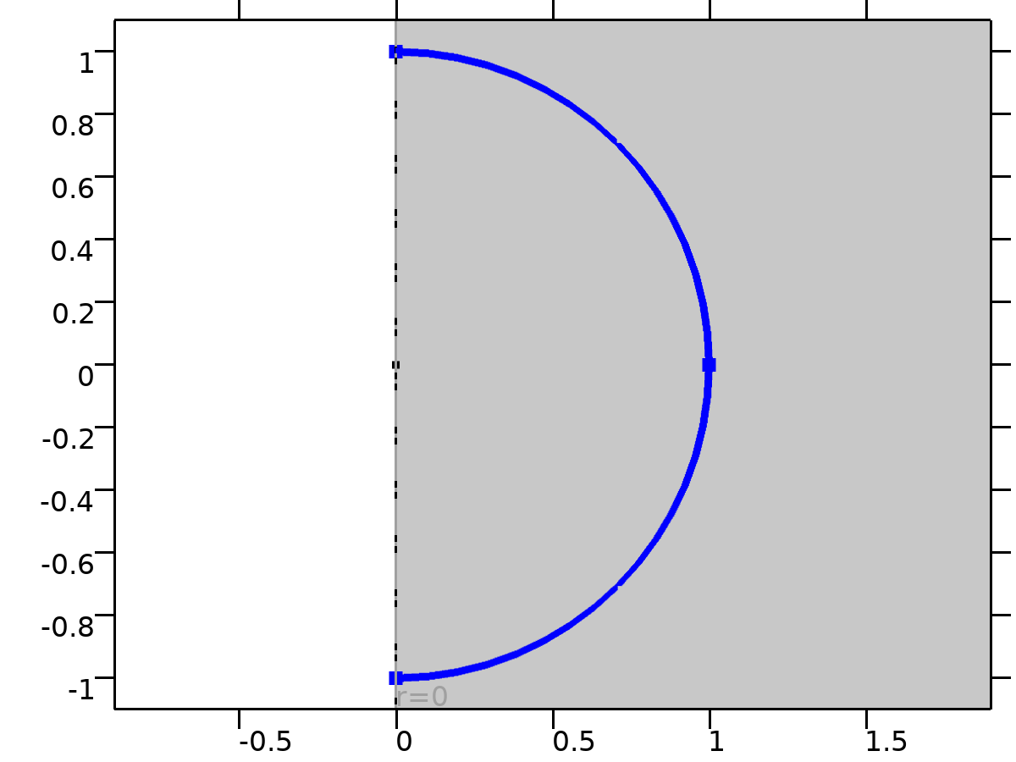

Selection

Advanced

| **Description** | **Value** |
| --- | --- |
| Compute integral in revolved geometry | On |

* + 1. Coordinate Systems

#### Boundary System 1

|  |  |
| --- | --- |
| Coordinate system type | Boundary system |
| Tag | sys1 |

Coordinate names

| **First** | **Second** | **Third** |
| --- | --- | --- |
| t1 | to | n |

* 1. Geometry 1

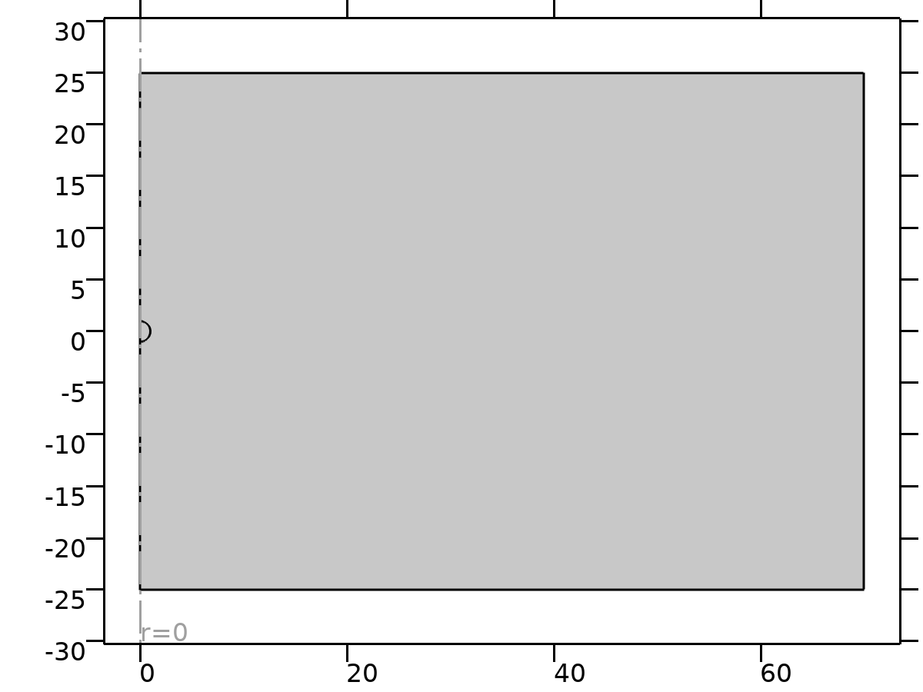

Geometry 1

Geometry statistics

| **Description** | **Value** |
| --- | --- |
| Space dimension | 2 |
| Number of domains | 2 |
| Number of boundaries | 9 |
| Number of vertices | 8 |

* + 1. Circle 1 (c1)

Position

| **Description** | **Value** |
| --- | --- |
| Position | {0, 0} |

Rotation angle

| **Description** | **Value** |
| --- | --- |
| Rotation | -90 |

Size and shape

| **Description** | **Value** |
| --- | --- |
| Radius | 1 |
| Sector angle | 180 |

* + 1. Rectangle 1 (r1)

Position

| **Description** | **Value** |
| --- | --- |
| Position | {0, -H/2} |

Size

| **Description** | **Value** |
| --- | --- |
| Width | W |
| Height | H |

* + 1. Rectangle 2 (r2)

Position

| **Description** | **Value** |
| --- | --- |
| Position | {0, -H/2} |

Size

| **Description** | **Value** |
| --- | --- |
| Width | 5 |
| Height | H |

* 1. Laminar Flow

Used products

|  |
| --- |
| COMSOL Multiphysics |

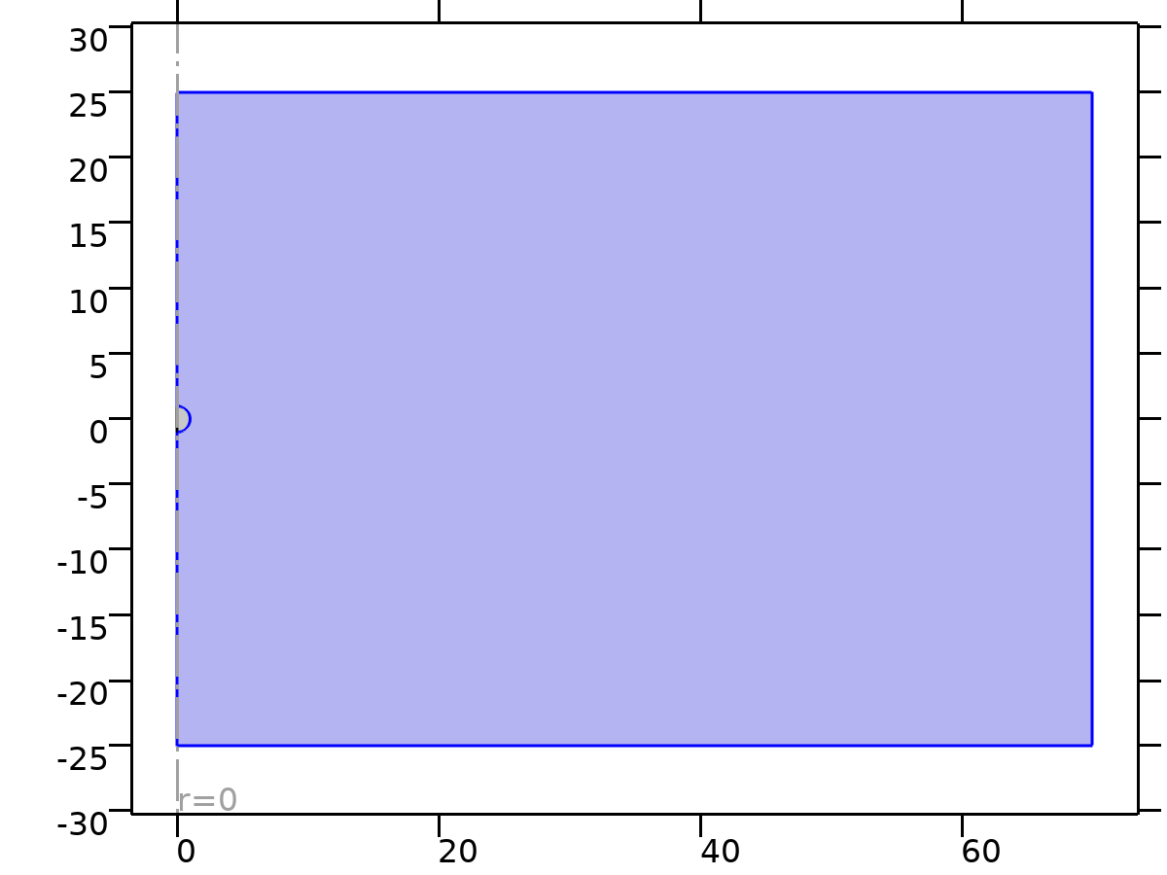

Laminar Flow

Selection

|  |  |
| --- | --- |
| Geometric entity level | Domain |
| Selection | Geometry geom1: Dimension 2: Domain 1 |

Equations





* + 1. Interface Settings

#### Discretization

Settings

| **Description** | **Value** |
| --- | --- |
| Discretization of fluids | P1 + P1 |

#### Physical Model

Settings

| **Description** | **Value** |
| --- | --- |
| Neglect inertial term (Stokes flow) | Off |
| Compressibility | Incompressible flow |
| Swirl flow | Off |
| Enable porous media domains | Off |
| Include gravity | Off |
| Reference temperature | User defined |
| Reference temperature | 293.15[K] |
| Reference pressure level | 1[atm] |

#### Turbulence

Settings

| **Description** | **Value** |
| --- | --- |
| Turbulence model type | None |

* + 1. Variables

| **Name** | **Expression** | **Description** | **Selection** | **Details** |
| --- | --- | --- | --- | --- |
| spf.Tref | model.input.Tref | Reference temperature | Global | Meta |
| spf.dz | 1 | Thickness | Domain 1 |  |
| spf.pref | 1[atm] | Reference pressure level | Domain 1 |  |
| spf.pA | p+spf.pref | Absolute pressure | Domain 1 |  |
| spf.hasWF | 0 | Help variable | Boundaries 1–2, 5–9 |  |
| spf.dt_CFL | 1/max(spf.maxop(sqrt(emetric_spatial(u-d(r,TIME),w-d(z,TIME)))),eps) | Time step, CFL=1 | Global |  |
| spf.Qvd_tot | spf.intop(2*spf.Qvd*pi*r) | Total viscous dissipation | Global |  |
| spf.K_stressr | spf.K_stress_tensorrr*spf.nrmesh+spf.K_stress_tensorrphi*spf.nphimesh+spf.K_stress_tensorrz*spf.nzmesh | Viscous force, exterior boundaries, r component | Boundaries 1–2, 5–9 |  |
| spf.K_stressphi | spf.K_stress_tensorphir*spf.nrmesh+spf.K_stress_tensorphiphi*spf.nphimesh+spf.K_stress_tensorphiz*spf.nzmesh | Viscous force, exterior boundaries, phi component | Boundaries 1–2, 5–9 |  |
| spf.K_stressz | spf.K_stress_tensorzr*spf.nrmesh+spf.K_stress_tensorzphi*spf.nphimesh+spf.K_stress_tensorzz*spf.nzmesh | Viscous force, exterior boundaries, z component | Boundaries 1–2, 5–9 |  |
| spf.T_stressr | spf.T_stress_tensorrr*spf.nrmesh+spf.T_stress_tensorrphi*spf.nphimesh+spf.T_stress_tensorrz*spf.nzmesh | Total traction, exterior boundaries, r component | Boundaries 1–2, 5–9 |  |
| spf.T_stressphi | spf.T_stress_tensorphir*spf.nrmesh+spf.T_stress_tensorphiphi*spf.nphimesh+spf.T_stress_tensorphiz*spf.nzmesh | Total traction, exterior boundaries, phi component | Boundaries 1–2, 5–9 |  |
| spf.T_stressz | spf.T_stress_tensorzr*spf.nrmesh+spf.T_stress_tensorzphi*spf.nphimesh+spf.T_stress_tensorzz*spf.nzmesh | Total traction, exterior boundaries, z component | Boundaries 1–2, 5–9 |  |
| spf.K_stress_dr | down(spf.K_stress_tensorrr)*spf.dnrmesh+down(spf.K_stress_tensorrphi)*spf.dnphimesh+down(spf.K_stress_tensorrz)*spf.dnzmesh | Viscous force, interior boundaries, downside, r component | Boundaries 1–2, 5–7 |  |
| spf.K_stress_dphi | down(spf.K_stress_tensorphir)*spf.dnrmesh+down(spf.K_stress_tensorphiphi)*spf.dnphimesh+down(spf.K_stress_tensorphiz)*spf.dnzmesh | Viscous force, interior boundaries, downside, phi component | Boundaries 1–2, 5–7 |  |
| spf.K_stress_dz | down(spf.K_stress_tensorzr)*spf.dnrmesh+down(spf.K_stress_tensorzphi)*spf.dnphimesh+down(spf.K_stress_tensorzz)*spf.dnzmesh | Viscous force, interior boundaries, downside, z component | Boundaries 1–2, 5–7 |  |
| spf.K_stress_ur | up(spf.K_stress_tensorrr)*spf.unrmesh+up(spf.K_stress_tensorrphi)*spf.unphimesh+up(spf.K_stress_tensorrz)*spf.unzmesh | Viscous force, interior boundaries, upside, r component | Boundaries 8–9 |  |
| spf.K_stress_uphi | up(spf.K_stress_tensorphir)*spf.unrmesh+up(spf.K_stress_tensorphiphi)*spf.unphimesh+up(spf.K_stress_tensorphiz)*spf.unzmesh | Viscous force, interior boundaries, upside, phi component | Boundaries 8–9 |  |
| spf.K_stress_uz | up(spf.K_stress_tensorzr)*spf.unrmesh+up(spf.K_stress_tensorzphi)*spf.unphimesh+up(spf.K_stress_tensorzz)*spf.unzmesh | Viscous force, interior boundaries, upside, z component | Boundaries 8–9 |  |
| spf.T_stress_dr | down(spf.T_stress_tensorrr)*spf.dnrmesh+down(spf.T_stress_tensorrphi)*spf.dnphimesh+down(spf.T_stress_tensorrz)*spf.dnzmesh | Total traction, interior boundaries, downside, r component | Boundaries 1–2, 5–7 |  |
| spf.T_stress_dphi | down(spf.T_stress_tensorphir)*spf.dnrmesh+down(spf.T_stress_tensorphiphi)*spf.dnphimesh+down(spf.T_stress_tensorphiz)*spf.dnzmesh | Total traction, interior boundaries, downside, phi component | Boundaries 1–2, 5–7 |  |
| spf.T_stress_dz | down(spf.T_stress_tensorzr)*spf.dnrmesh+down(spf.T_stress_tensorzphi)*spf.dnphimesh+down(spf.T_stress_tensorzz)*spf.dnzmesh | Total traction, interior boundaries, downside, z component | Boundaries 1–2, 5–7 |  |
| spf.T_stress_ur | up(spf.T_stress_tensorrr)*spf.unrmesh+up(spf.T_stress_tensorrphi)*spf.unphimesh+up(spf.T_stress_tensorrz)*spf.unzmesh | Total traction, interior boundaries, upside, r component | Boundaries 8–9 |  |
| spf.T_stress_uphi | up(spf.T_stress_tensorphir)*spf.unrmesh+up(spf.T_stress_tensorphiphi)*spf.unphimesh+up(spf.T_stress_tensorphiz)*spf.unzmesh | Total traction, interior boundaries, upside, phi component | Boundaries 8–9 |  |
| spf.T_stress_uz | up(spf.T_stress_tensorzr)*spf.unrmesh+up(spf.T_stress_tensorzphi)*spf.unphimesh+up(spf.T_stress_tensorzz)*spf.unzmesh | Total traction, interior boundaries, upside, z component | Boundaries 8–9 |  |
| spf.usePseudoTimeStepping | 0 | Help variable | Global | + operation |
| spf.localCFLvalue | 1.3^min(niterCMP,9)+if(niterCMP>=25,9*1.3^min(-25+niterCMP,9),0)+if(niterCMP>=45,90*1.3^min(-45+niterCMP,9),0) | Local CFL number | Domain 1 |  |
| spf.locCFL | CFLCMP | Local CFL number | Domain 1 |  |
| spf.geometryLengthScale | 12.5 | Geometry length scale | Domain 1 |  |
| spf.time_step_inv | max(sqrt(emetric_spatial(u,w)*2^gmg_level^2),spf.nu/spf.geometryLengthScale^2) | Inverse time step | Domain 1 |  |
| spf.tsti | nojac(spf.time_step_inv/spf.locCFL) | Help variable | Domain 1 |  |
| spf.nr | unr | Normal vector, r component | Boundaries 8–9 |  |
| spf.nphi | 0 | Normal vector, phi component | Boundaries 8–9 |  |
| spf.nz | unz | Normal vector, z component | Boundaries 8–9 |  |
| spf.nr | dnr | Normal vector, r component | Boundaries 1–2, 5–7 |  |
| spf.nphi | 0 | Normal vector, phi component | Boundaries 1–2, 5–7 |  |
| spf.nz | dnz | Normal vector, z component | Boundaries 1–2, 5–7 |  |
| spf.nrmesh | unrmesh | Normal vector, r component | Boundaries 8–9 |  |
| spf.nphimesh | 0 | Normal vector, phi component | Boundaries 8–9 |  |
| spf.nzmesh | unzmesh | Normal vector, z component | Boundaries 8–9 |  |
| spf.nrmesh | dnrmesh | Normal vector, r component | Boundaries 1–2, 5–7 |  |
| spf.nphimesh | 0 | Normal vector, phi component | Boundaries 1–2, 5–7 |  |
| spf.nzmesh | dnzmesh | Normal vector, z component | Boundaries 1–2, 5–7 |  |

* + 1. Fluid Properties 1



Fluid Properties 1

Selection

|  |  |
| --- | --- |
| Geometric entity level | Domain |
| Selection | Geometry geom1: Dimension 2: All domains |

Equations

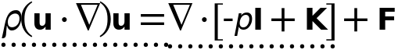



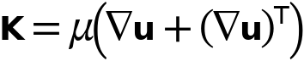

#### Fluid Properties

Settings

| **Description** | **Value** |
| --- | --- |
| Density | User defined |
| Density | Re |
|  | Newtonian |
| Dynamic viscosity | User defined |
| Dynamic viscosity | 1 |

#### Variables

| **Name** | **Expression** | **Description** | **Selection** | **Details** |
| --- | --- | --- | --- | --- |
| spf.mu | material.mu | Dynamic viscosity | Domain 1 | Meta |
| spf.rho | material.rho | Density | Domain 1 | Meta |
| spf.Trho | spf.fp1.minput_temperature | Temperature for density evaluation | Domain 1 |  |
| spf.prho | spf.fp1.minput_pressure | Pressure for the evaluation of density | Domain 1 |  |
| spf.rhoref | subst(material.rho,minput.T,spf.Tref,minput.pA,spf.pref) | Reference density | Domain 1 | Meta |
| spf.mumat | material.mu | Dynamic viscosity | Domain 1 | Meta |
| spf.srijrr | ur | Strain rate tensor, rr component | Domain 1 |  |
| spf.srijphir | 0 | Strain rate tensor, phir component | Domain 1 |  |
| spf.srijzr | 0.5*(wr+uz) | Strain rate tensor, zr component | Domain 1 |  |
| spf.srijrphi | 0 | Strain rate tensor, rphi component | Domain 1 |  |
| spf.srijphiphi | if(abs(r)<0.001*h_spatial,ur,u/r) | Strain rate tensor, phiphi component | Domain 1 |  |
| spf.srijzphi | 0 | Strain rate tensor, zphi component | Domain 1 |  |
| spf.srijrz | 0.5*(uz+wr) | Strain rate tensor, rz component | Domain 1 |  |
| spf.srijphiz | 0 | Strain rate tensor, phiz component | Domain 1 |  |
| spf.srijzz | wz | Strain rate tensor, zz component | Domain 1 |  |
| spf.rrijrr | 0 | Rotation rate tensor, rr component | Domain 1 |  |
| spf.rrijphir | 0 | Rotation rate tensor, phir component | Domain 1 |  |
| spf.rrijzr | 0.5*(wr-uz) | Rotation rate tensor, zr component | Domain 1 |  |
| spf.rrijrphi | 0 | Rotation rate tensor, rphi component | Domain 1 |  |
| spf.rrijphiphi | 0 | Rotation rate tensor, phiphi component | Domain 1 |  |
| spf.rrijzphi | 0 | Rotation rate tensor, zphi component | Domain 1 |  |
| spf.rrijrz | 0.5*(uz-wr) | Rotation rate tensor, rz component | Domain 1 |  |
| spf.rrijphiz | 0 | Rotation rate tensor, phiz component | Domain 1 |  |
| spf.rrijzz | 0 | Rotation rate tensor, zz component | Domain 1 |  |
| spf.sr | sqrt(2*spf.srijrr^2+2*spf.srijrphi^2+2*spf.srijrz^2+2*spf.srijphir^2+2*spf.srijphiphi^2+2*spf.srijphiz^2+2*spf.srijzr^2+2*spf.srijzphi^2+2*spf.srijzz^2+eps) | Shear rate | Domain 1 |  |
| spf.rr | sqrt(2*spf.rrijrr^2+2*spf.rrijrphi^2+2*spf.rrijrz^2+2*spf.rrijphir^2+2*spf.rrijphiphi^2+2*spf.rrijphiz^2+2*spf.rrijzr^2+2*spf.rrijzphi^2+2*spf.rrijzz^2+eps) | Rotation rate | Domain 1 |  |
| spf.divu | ur+if(abs(r)<0.001*h_spatial,ur,u/r)+wz | Divergence of velocity field | Domain 1 |  |
| spf.Fr | 0 | Volume force, r component | Domain 1 | + operation |
| spf.Fphi | 0 | Volume force, phi component | Domain 1 | + operation |
| spf.Fz | 0 | Volume force, z component | Domain 1 | + operation |
| spf.U | sqrt(u^2+w^2) | Velocity magnitude | Domain 1 |  |
| spf.vorticityr | 0 | Vorticity field, r component | Domain 1 |  |
| spf.vorticityphi | -wr+uz | Vorticity field, phi component | Domain 1 |  |
| spf.vorticityz | 0 | Vorticity field, z component | Domain 1 |  |
| spf.vort_magn | sqrt(spf.vorticityr^2+spf.vorticityphi^2+spf.vorticityz^2) | Vorticity magnitude | Domain 1 |  |
| spf.cellRe | 0.25*spf.rho*sqrt(emetric_spatial(u-d(r,TIME),w-d(z,TIME))/emetric2_spatial)/spf.mu | Cell Reynolds number | Domain 1 |  |
| spf.nu | spf.mu/spf.rho | Kinematic viscosity | Domain 1 |  |
| spf.betaT | 0 | Isothermal compressibility coefficient | Domain 1 |  |
| spf.Qm | 0 | Source term | Domain 1 | + operation |
| spf.Fgtotr | 0 | Gravity force, r component | Domain 1 | + operation |
| spf.Fgtotphi | 0 | Gravity force, phi component | Domain 1 | + operation |
| spf.Fgtotz | 0 | Gravity force, z component | Domain 1 | + operation |
| spf.mu_eff | spf.mu+spf.muT | Dynamic viscosity | Domain 1 |  |
| spf.muT | 0 | Turbulent dynamic viscosity | Domain 1 |  |
| spf.T_stress_tensorrr | spf.K_stress_tensorrr-p | Total stress tensor, rr component | Domain 1 | + operation |
| spf.T_stress_tensorphir | spf.K_stress_tensorphir | Total stress tensor, phir component | Domain 1 | + operation |
| spf.T_stress_tensorzr | spf.K_stress_tensorzr | Total stress tensor, zr component | Domain 1 | + operation |
| spf.T_stress_tensorrphi | spf.K_stress_tensorrphi | Total stress tensor, rphi component | Domain 1 | + operation |
| spf.T_stress_tensorphiphi | spf.K_stress_tensorphiphi-p | Total stress tensor, phiphi component | Domain 1 | + operation |
| spf.T_stress_tensorzphi | spf.K_stress_tensorzphi | Total stress tensor, zphi component | Domain 1 | + operation |
| spf.T_stress_tensorrz | spf.K_stress_tensorrz | Total stress tensor, rz component | Domain 1 | + operation |
| spf.T_stress_tensorphiz | spf.K_stress_tensorphiz | Total stress tensor, phiz component | Domain 1 | + operation |
| spf.T_stress_tensorzz | spf.K_stress_tensorzz-p | Total stress tensor, zz component | Domain 1 | + operation |
| spf.K_stress_tensorrr | 2*spf.mu_eff*ur | Viscous stress tensor, rr component | Domain 1 | + operation |
| spf.K_stress_tensorphir | 0 | Viscous stress tensor, phir component | Domain 1 | + operation |
| spf.K_stress_tensorzr | spf.mu_eff*(wr+uz) | Viscous stress tensor, zr component | Domain 1 | + operation |
| spf.K_stress_tensorrphi | 0 | Viscous stress tensor, rphi component | Domain 1 | + operation |
| spf.K_stress_tensorphiphi | 2*spf.mu_eff*if(abs(r)<0.001*h_spatial,ur,u/r) | Viscous stress tensor, phiphi component | Domain 1 | + operation |
| spf.K_stress_tensorzphi | 0 | Viscous stress tensor, zphi component | Domain 1 | + operation |
| spf.K_stress_tensorrz | spf.mu_eff*(uz+wr) | Viscous stress tensor, rz component | Domain 1 | + operation |
| spf.K_stress_tensorphiz | 0 | Viscous stress tensor, phiz component | Domain 1 | + operation |
| spf.K_stress_tensorzz | 2*spf.mu_eff*wz | Viscous stress tensor, zz component | Domain 1 | + operation |
| spf.K_stress_tensor_testrr | 2*spf.mu_eff*test(ur) | Viscous stress tensor test, rr component | Domain 1 | + operation |
| spf.K_stress_tensor_testphir | 0 | Viscous stress tensor test, phir component | Domain 1 | + operation |
| spf.K_stress_tensor_testzr | spf.mu_eff*(test(wr)+test(uz)) | Viscous stress tensor test, zr component | Domain 1 | + operation |
| spf.K_stress_tensor_testrphi | 0 | Viscous stress tensor test, rphi component | Domain 1 | + operation |
| spf.K_stress_tensor_testphiphi | 2*spf.mu_eff*if(abs(r)<0.001*h_spatial,test(ur),test(u)/r) | Viscous stress tensor test, phiphi component | Domain 1 | + operation |
| spf.K_stress_tensor_testzphi | 0 | Viscous stress tensor test, zphi component | Domain 1 | + operation |
| spf.K_stress_tensor_testrz | spf.mu_eff*(test(uz)+test(wr)) | Viscous stress tensor test, rz component | Domain 1 | + operation |
| spf.K_stress_tensor_testphiz | 0 | Viscous stress tensor test, phiz component | Domain 1 | + operation |
| spf.K_stress_tensor_testzz | 2*spf.mu_eff*test(wz) | Viscous stress tensor test, zz component | Domain 1 | + operation |
| spf.upwind_helpr | u-d(r,TIME) | Upwind term, r component | Domain 1 | + operation |
| spf.upwind_helpphi | 0 | Upwind term, phi component | Domain 1 | + operation |
| spf.upwind_helpz | w-d(z,TIME) | Upwind term, z component | Domain 1 | + operation |
| spf.tau_vdrr | 2*spf.mu*spf.srijrr | Viscous stress tensor, rr component | Domain 1 | + operation |
| spf.tau_vdphir | 2*spf.mu*spf.srijphir | Viscous stress tensor, phir component | Domain 1 | + operation |
| spf.tau_vdzr | 2*spf.mu*spf.srijzr | Viscous stress tensor, zr component | Domain 1 | + operation |
| spf.tau_vdrphi | 2*spf.mu*spf.srijrphi | Viscous stress tensor, rphi component | Domain 1 | + operation |
| spf.tau_vdphiphi | 2*spf.mu*spf.srijphiphi | Viscous stress tensor, phiphi component | Domain 1 | + operation |
| spf.tau_vdzphi | 2*spf.mu*spf.srijzphi | Viscous stress tensor, zphi component | Domain 1 | + operation |
| spf.tau_vdrz | 2*spf.mu*spf.srijrz | Viscous stress tensor, rz component | Domain 1 | + operation |
| spf.tau_vdphiz | 2*spf.mu*spf.srijphiz | Viscous stress tensor, phiz component | Domain 1 | + operation |
| spf.tau_vdzz | 2*spf.mu*spf.srijzz | Viscous stress tensor, zz component | Domain 1 | + operation |
| spf.Qvd | spf.tau_vdrr*ur+spf.tau_vdrz*uz+spf.tau_vdphiphi*if(abs(r)<0.001*h_spatial,ur,u/r)+spf.tau_vdzr*wr+spf.tau_vdzz*wz | Viscous dissipation | Domain 1 | + operation |
| spf.epsilon_p | 1 | Porosity | Domain 1 |  |
| spf.Fst_tensorrr | 0 | Surface tension force, rr component | Domain 1 | + operation |
| spf.Fst_tensorphir | 0 | Surface tension force, phir component | Domain 1 | + operation |
| spf.Fst_tensorzr | 0 | Surface tension force, zr component | Domain 1 | + operation |
| spf.Fst_tensorrphi | 0 | Surface tension force, rphi component | Domain 1 | + operation |
| spf.Fst_tensorphiphi | 0 | Surface tension force, phiphi component | Domain 1 | + operation |
| spf.Fst_tensorzphi | 0 | Surface tension force, zphi component | Domain 1 | + operation |
| spf.Fst_tensorrz | 0 | Surface tension force, rz component | Domain 1 | + operation |
| spf.Fst_tensorphiz | 0 | Surface tension force, phiz component | Domain 1 | + operation |
| spf.Fst_tensorzz | 0 | Surface tension force, zz component | Domain 1 | + operation |
| spf.continuityEquation | spf.rho*spf.divu | Continuity equation | Domain 1 |  |
| spf.contCoeff | spf.rho | Help variable | Domain 1 |  |
| spf.res_u | pr+spf.rho*u*ur+spf.rho*w*uz-(d(2*ur,r)+if(abs(r)<0.001*h_spatial,d(2*ur,r),2*ur/r)+d(uz+wr,z)-2*if(abs(r)<0.001*h_spatial,ur,u/r)/r)*spf.mu-spf.Fr | Equation residual | Domain 1 |  |
| spf.res_v | -spf.Fphi | Equation residual | Domain 1 |  |
| spf.res_w | spf.rho*u*wr+pz+spf.rho*w*wz-(d(wr+uz,r)+if(abs(r)<0.001*h_spatial,d(wr+uz,r),(wr+uz)/r)+d(2*wz,z))*spf.mu-spf.Fz | Equation residual | Domain 1 |  |
| spf.res_p | spf.rho*spf.divu | Pressure equation residual | Domain 1 |  |

#### Shape functions

| **Name** | **Shape function** | **Description** | **Shape frame** | **Selection** |
| --- | --- | --- | --- | --- |
| u | Lagrange (Linear) | Velocity field, r component | Spatial | Domain 1 |
| w | Lagrange (Linear) | Velocity field, z component | Spatial | Domain 1 |
| p | Lagrange (Linear) | Pressure | Spatial | Domain 1 |

#### Weak Expressions

| **Weak expression** | **Integration order** | **Integration frame** | **Selection** |
| --- | --- | --- | --- |
| 2*((p-spf.K_stress_tensorrr)*test(ur)-spf.K_stress_tensorrz*test(uz)+(p-spf.K_stress_tensorphiphi)*if(abs(r)<0.001*h_spatial,test(ur),test(u)/r)-spf.K_stress_tensorzr*test(wr)+(p-spf.K_stress_tensorzz)*test(wz))*pi*r | 2 | Spatial | Domain 1 |
| 2*(spf.Fr*test(u)+spf.Fz*test(w))*pi*r | 2 | Spatial | Domain 1 |
| 2*spf.rho*(-(d(u,r)*u+d(u,z)*w)*test(u)-(d(w,r)*u+d(w,z)*w)*test(w))*pi*r | 2 | Spatial | Domain 1 |
| -2*spf.continuityEquation*test(p)*pi*r | 2 | Spatial | Domain 1 |
| 2*spf.streamlinens*pi*r | 2 | Spatial | Domain 1 |
| 2*spf.crosswindns*pi*r | 2 | Spatial | Domain 1 |
| 2*(spf.usePseudoTimeStepping>0)*spf.rho*spf.tsti*(-(u-nojac(u))*test(u)-(w-nojac(w))*test(w))*pi*r | 2 | Spatial | Domain 1 |

* + 1. Initial Values 1



Initial Values 1

Selection

|  |  |
| --- | --- |
| Geometric entity level | Domain |
| Selection | Geometry geom1: Dimension 2: All domains |

#### Initial Values

Settings

| **Description** | **Value** |
| --- | --- |
| Velocity field, r component | 0 |
| Velocity field, phi component | 0 |
| Velocity field, z component | 0 |
| Pressure | 0 |

#### Coordinate System Selection

Settings

| **Description** | **Value** |
| --- | --- |
| Coordinate system | Global coordinate system |

#### Variables

| **Name** | **Expression** | **Description** | **Selection** | **Details** |
| --- | --- | --- | --- | --- |
| spf.u_initr | 0 | Velocity field, r component | Domain 1 |  |
| spf.u_initphi | 0 | Velocity field, phi component | Domain 1 |  |
| spf.u_initz | 0 | Velocity field, z component | Domain 1 |  |
| spf.p_init | 0 | Pressure | Domain 1 |  |

* + 1. Axial Symmetry 1

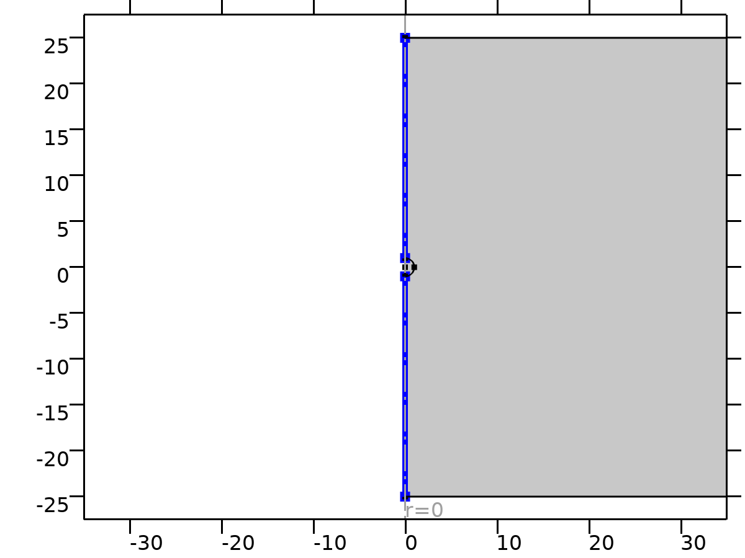

Axial Symmetry 1

Selection

|  |  |
| --- | --- |
| Geometric entity level | Boundary |
| Selection | Geometry geom1: Dimension 1: All boundaries |

#### Constraints

| **Constraint** | **Constraint force** | **Shape function** | **Selection** | **Details** |
| --- | --- | --- | --- | --- |
| -u | test(-u) | Lagrange (Linear) | Boundaries 1, 5 | Elemental |

* + 1. Wall 1

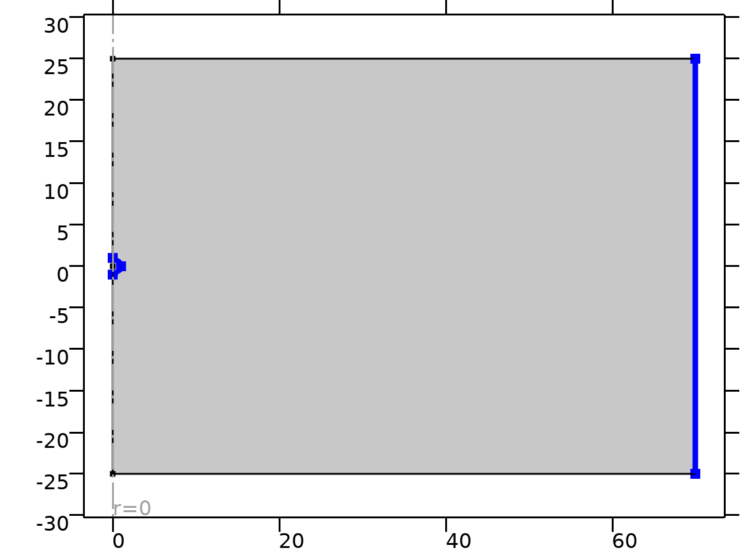

Wall 1

Selection

|  |  |
| --- | --- |
| Geometric entity level | Boundary |
| Selection | Geometry geom1: Dimension 1: All boundaries |

Equations



#### Boundary Condition

Settings

| **Description** | **Value** |
| --- | --- |
| Wall condition | No slip |

#### Wall Movement

Settings

| **Description** | **Value** |
| --- | --- |
| Translational velocity | Automatic from frame |
| Sliding wall | Off |

#### Variables

| **Name** | **Expression** | **Description** | **Selection** | **Details** |
| --- | --- | --- | --- | --- |
| spf.ubndr | spf.utrr+spf.usr | Velocity at boundary, r component | Boundaries 7–9 |  |
| spf.ubndphi | spf.utrphi+spf.usphi | Velocity at boundary, phi component | Boundaries 7–9 |  |
| spf.ubndz | spf.utrz+spf.usz | Velocity at boundary, z component | Boundaries 7–9 |  |
| spf.usr | 0 | Velocity of sliding wall, r component | Boundaries 7–9 |  |
| spf.usphi | 0 | Velocity of sliding wall, phi component | Boundaries 7–9 |  |
| spf.usz | 0 | Velocity of sliding wall, z component | Boundaries 7–9 |  |
| spf.utrr | 0 | Velocity of moving wall, r component | Boundaries 7–9 |  |
| spf.utrphi | 0 | Velocity of moving wall, phi component | Boundaries 7–9 |  |
| spf.utrz | 0 | Velocity of moving wall, z component | Boundaries 7–9 |  |
| spf.uLeakager | 0 | Leakage velocity, r component | Boundaries 7–9 | + operation |
| spf.uLeakagephi | 0 | Leakage velocity, phi component | Boundaries 7–9 | + operation |
| spf.uLeakagez | 0 | Leakage velocity, z component | Boundaries 7–9 | + operation |
| spf.noSlipWall | 1 | Help variable | Boundaries 7–9 |  |

#### Constraints

| **Constraint** | **Constraint force** | **Shape function** | **Selection** | **Details** |
| --- | --- | --- | --- | --- |
| -u+spf.ubndr+spf.uLeakager | test(-u) | Lagrange (Linear) | Boundaries 7–9 | Elemental |
| spf.ubndphi+spf.uLeakagephi | 0 |  | Boundaries 7–9 | Elemental |
| -w+spf.ubndz+spf.uLeakagez | test(-w) | Lagrange (Linear) | Boundaries 7–9 | Elemental |

* + 1. Inlet 1

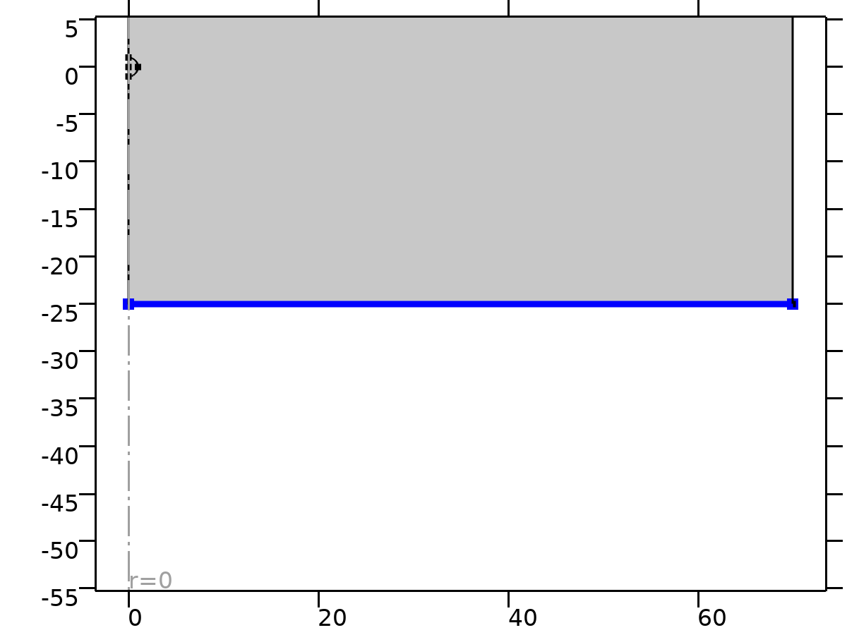

Inlet 1

Selection

|  |  |
| --- | --- |
| Geometric entity level | Boundary |
| Selection | Geometry geom1: Dimension 1: Boundary 2 |

Equations



#### Boundary Condition

Settings

| **Description** | **Value** |
| --- | --- |
| Boundary condition | Velocity |

#### Velocity

Settings

| **Description** | **Value** |
| --- | --- |
| Velocity field componentwise | Velocity field |
| Velocity field, r component | 0 |
| Velocity field, phi component | 0 |
| Velocity field, z component | 1 |

#### Variables

| **Name** | **Expression** | **Description** | **Selection** | **Details** |
| --- | --- | --- | --- | --- |
| spf.u0r | 0 | Velocity field, r component | Boundary 2 |  |
| spf.u0phi | 0 | Velocity field, phi component | Boundary 2 |  |
| spf.u0z | 1 | Velocity field, z component | Boundary 2 |  |
| spf.inl1.dz | spf.dz | Channel thickness | Boundary 2 |  |
| spf.inl1.volumeFlowRate | spf.inl1.intop(2*(u*spf.nrmesh+w*spf.nzmesh)*pi*r) | Outward volume flow rate across feature selection | Global |  |
| spf.inl1.massFlowRate | spf.inl1.intop(2*spf.rho*(u*spf.nrmesh+w*spf.nzmesh)*pi*r) | Outward mass flow rate across feature selection | Global |  |
| spf.inl1.pAverage | spf.inl1.intop(2*p*pi*r)/max(spf.inl1.intop(2*pi*r),1000*eps) | Pressure average over feature selection | Global |  |

#### Constraints

| **Constraint** | **Constraint force** | **Shape function** | **Selection** | **Details** |
| --- | --- | --- | --- | --- |
| -u+spf.u0r | test(-u) | Lagrange (Linear) | Boundary 2 | Elemental |
| spf.u0phi | 0 |  | Boundary 2 | Elemental |
| -w+spf.u0z | test(-w) | Lagrange (Linear) | Boundary 2 | Elemental |

* + 1. Outlet 1

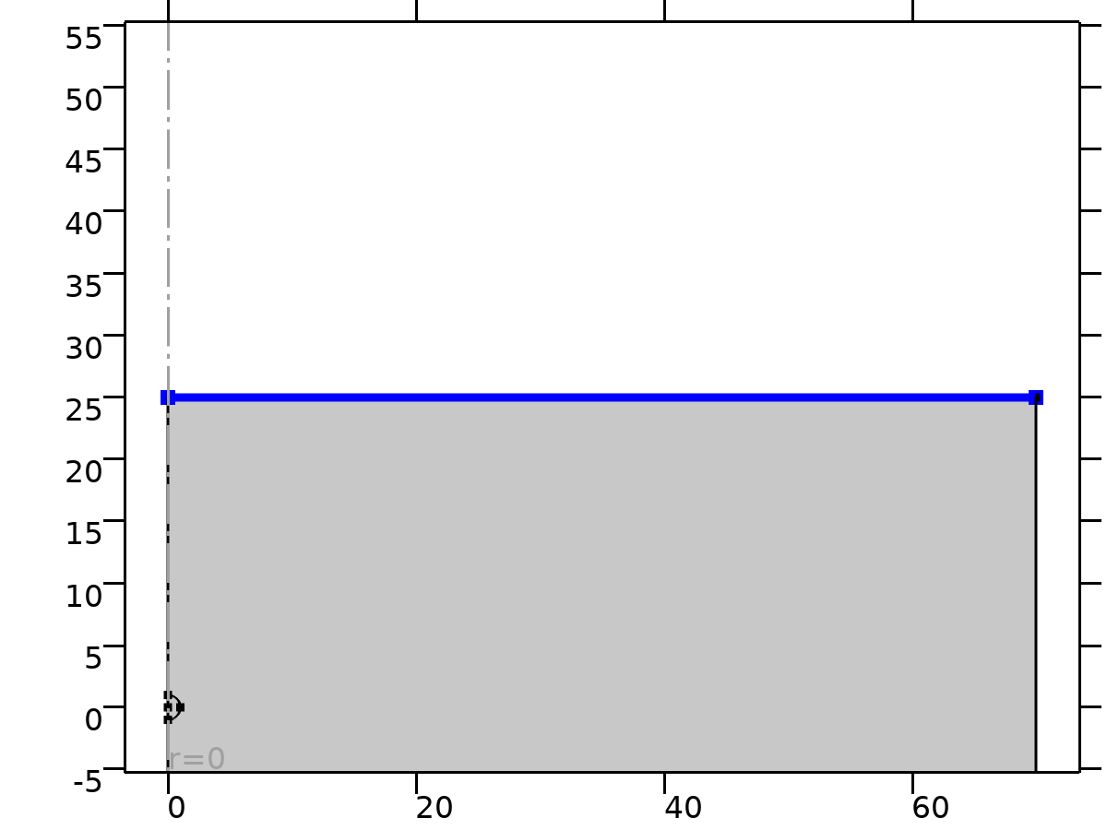

Outlet 1

Selection

|  |  |
| --- | --- |
| Geometric entity level | Boundary |
| Selection | Geometry geom1: Dimension 1: Boundary 6 |

Equations





#### Boundary Condition

Settings

| **Description** | **Value** |
| --- | --- |
| Boundary condition | Pressure |

#### Pressure Conditions

Settings

| **Description** | **Value** |
| --- | --- |
| Pressure | Static |
| Pressure | 0 |
| Normal flow | Off |
| Suppress backflow | On |

#### Variables

| **Name** | **Expression** | **Description** | **Selection** | **Details** |
| --- | --- | --- | --- | --- |
| spf.meshVol | meshvol_spatial |  | Boundary 6 |  |
| spf.meshVolInt | down(meshvol_spatial) | Volume of interior mesh element | Boundary 6 |  |
| spf.c_here | 96/spf.epsilon_p | Intermediate variable | Boundary 6 |  |
| spf.rhoFace | down(spf.rho) | Density face value | Boundary 6 |  |
| spf.umxTnFace | spf.upwind_helpr*spf.nrmesh+spf.upwind_helpphi*spf.nphimesh+spf.upwind_helpz*spf.nzmesh | Relative velocity on face | Boundary 6 |  |
| spf.upwind_ns | spf.backflowPenaltyConv*spf.uNormal | Upwind term | Boundary 6 |  |
| spf.p0 | 0 | Pressure | Boundary 6 |  |
| spf.out1.Uav | 0 | Average velocity | Global |  |
| spf.out1.p0avfdf | 0 | Average pressure | Global |  |
| spf.out1.dz | spf.dz | Channel thickness | Boundary 6 |  |
| spf.out1.Mflow | spf.out1.massFlowRate | Mass flow | Global |  |
| spf.f0 | spf.p0+spf.uNormal*(spf.backflowPenaltyDiff-spf.backflowPenaltyConv)*(spf.uNormal<0) | Normal stress | Boundary 6 |  |
| spf.uNormal | u*nojac(spf.nrmesh)+w*nojac(spf.nzmesh) | Normal velocity | Boundary 6 |  |
| spf.backflowPenaltyDiff | spf.c_here*min((down(spf.mu)+spf.muT)*spf.meshVol/spf.meshVolInt,down(spf.rho)*abs(spf.uNormal)/down(spf.epsilon_p)) | Backflow penalty parameter, diffusive contribution | Boundary 6 |  |
| spf.backflowPenaltyConv | spf.rhoFace*spf.umxTnFace/spf.epsilon_p^2 | Backflow penalty parameter, convective contribution | Boundary 6 |  |
| spf.out1.volumeFlowRate | spf.out1.intop(2*(u*spf.nrmesh+w*spf.nzmesh)*pi*r) | Outward volume flow rate across feature selection | Global |  |
| spf.out1.massFlowRate | spf.out1.intop(2*spf.rho*(u*spf.nrmesh+w*spf.nzmesh)*pi*r) | Outward mass flow rate across feature selection | Global |  |
| spf.out1.pAverage | spf.out1.intop(2*p*pi*r)/max(spf.out1.intop(2*pi*r),1000*eps) | Pressure average over feature selection | Global |  |

#### Weak Expressions

| **Weak expression** | **Integration order** | **Integration frame** | **Selection** |
| --- | --- | --- | --- |
| -2*spf.f0*(test(u)*spf.nrmesh+test(w)*spf.nzmesh)*pi*r | 2 | Spatial | Boundary 6 |

* 1. Mesh 1

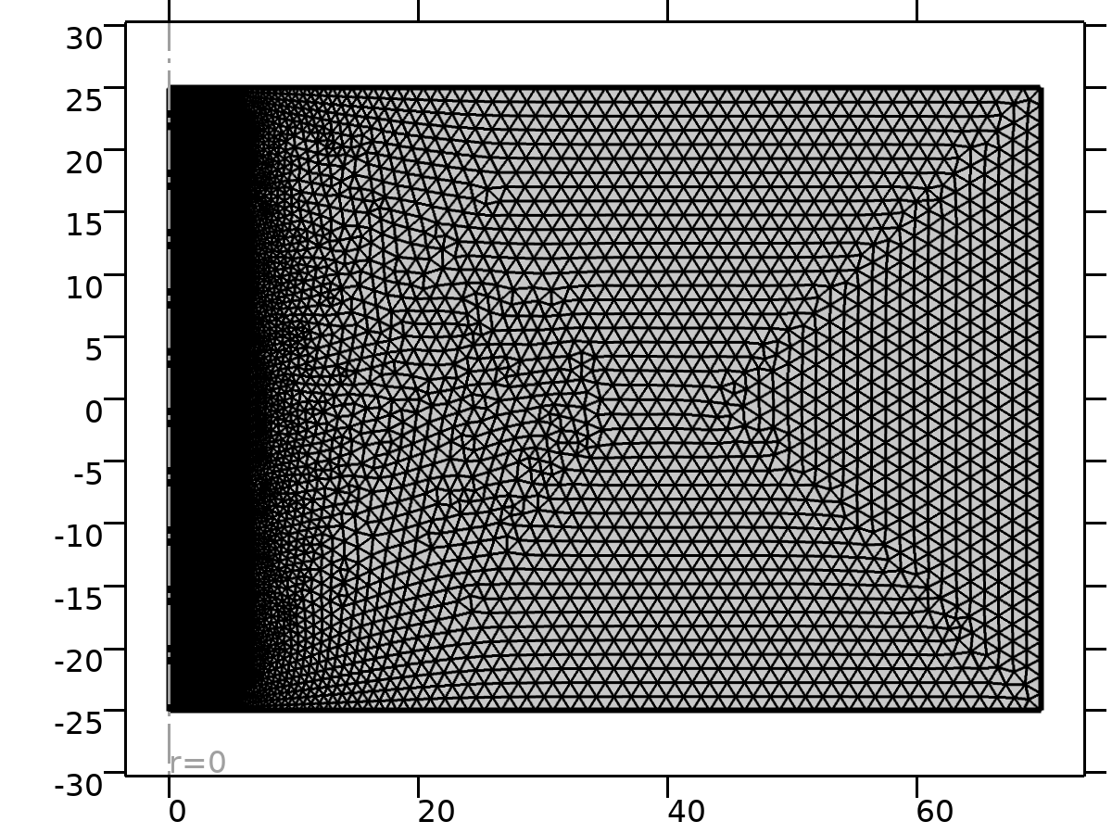

Mesh 1

Mesh statistics

| **Description** | **Value** |
| --- | --- |
| Minimum element quality | 0.7384 |
| Average element quality | 0.9821 |
| Triangle | 14068 |
| Edge element | 360 |
| Vertex element | 8 |

* + 1. Size (size)

Settings

| **Description** | **Value** |
| --- | --- |
| Calibrate for | Fluid dynamics |
| Maximum element size | 1.4 |
| Minimum element size | 0.02 |
| Curvature factor | 0.25 |
| Predefined size | Finer |

* + 1. Free Triangular 2 (ftri2)

Selection

|  |  |
| --- | --- |
| Geometric entity level | Domain |
| Selection | Remaining |

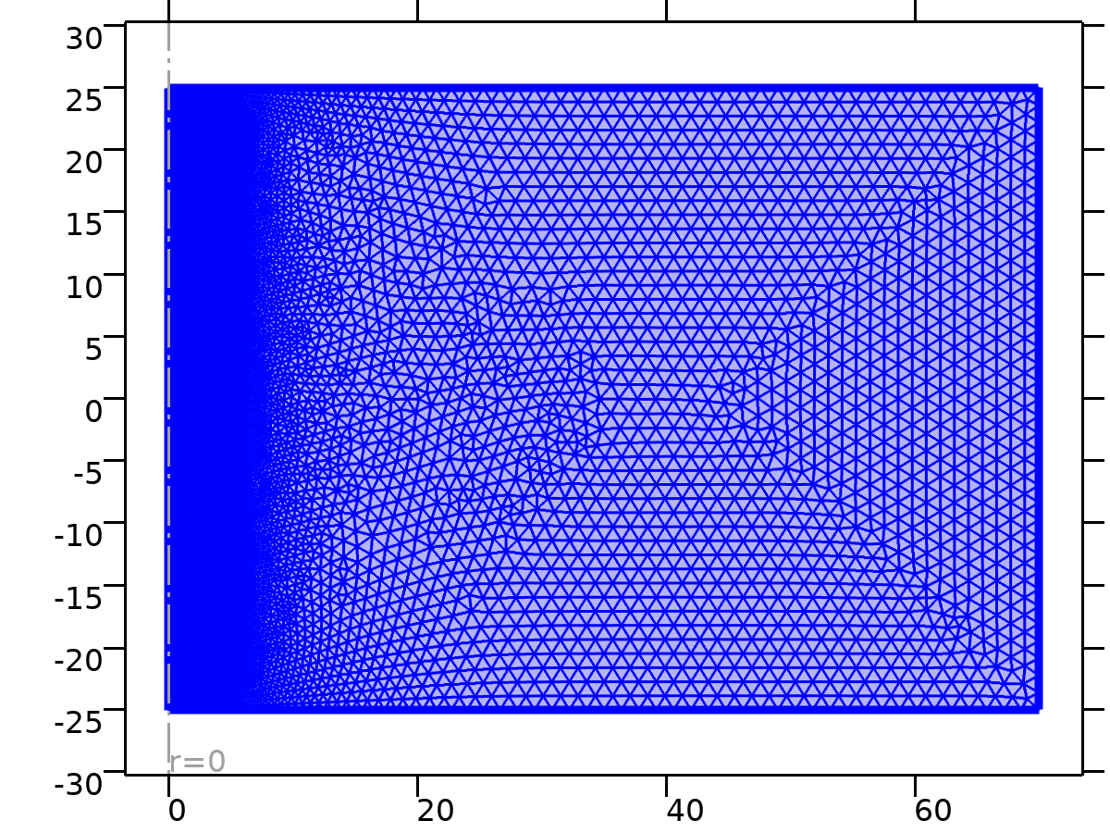

Free Triangular 2

Settings

| **Description** | **Value** |
| --- | --- |
| Number of iterations | 4 |
| Maximum element depth to process | 4 |

#### Size 1 (size1)

Selection

|  |  |
| --- | --- |
| Geometric entity level | Domain |
| Selection | Geometry geom1: Dimension 2: Domain 1 |

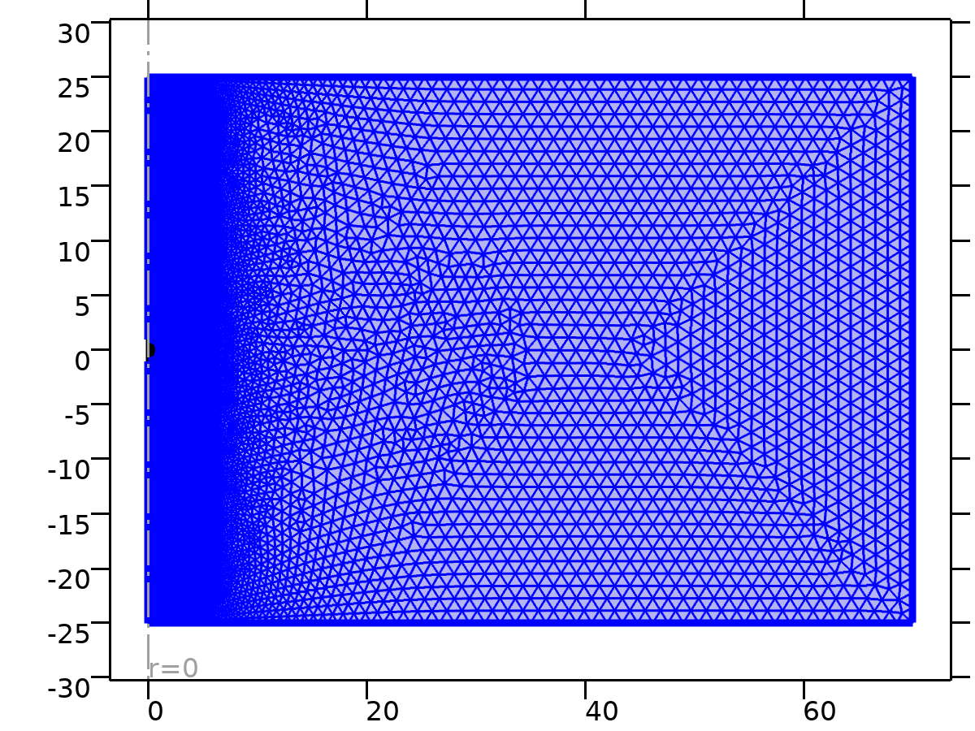

Size 1

Settings

| **Description** | **Value** |
| --- | --- |
| Calibrate for | Fluid dynamics |
| Maximum element size | 0.335 |
| Minimum element size | 0.001 |
| Curvature factor | 0.2 |
| Maximum element growth rate | 1.05 |
| Predefined size | Extremely fine |

1. Study 1

Computation information

|  |  |
| --- | --- |
| Computation time | 4 min 46 s |

* 1. Stationary

Study settings

| **Description** | **Value** |
| --- | --- |
| Include geometric nonlinearity | Off |

Study extensions

| **Description** | **Value** |
| --- | --- |
| Auxiliary sweep | On |
| Sweep type | All combinations |

Parameters

| **Parameter name** | **Parameter value list** | **Parameter unit** |
| --- | --- | --- |
| Re | range(0.1,0.1,100) |  |

Physics and variables selection

| **Physics interface** | **Discretization** |
| --- | --- |
| Laminar Flow (spf) | physics |

Mesh selection

| **Geometry** | **Mesh** |
| --- | --- |
| Geometry 1 (geom1) | mesh1 |

* + 1. Study extensions

Study extensions

| **Description** | **Value** |
| --- | --- |
| Auxiliary sweep | On |
| Sweep type | All combinations |

Parameters

| **Parameter name** | **Parameter value list** | **Parameter unit** |
| --- | --- | --- |
| Re | range(0.1,0.1,100) |  |

* 1. Solver Configurations
     1. Solution 1

#### Compile Equations: Stationary (st1)

Study and step

| **Description** | **Value** |
| --- | --- |
| Use study | Study 1 |
| Use study step | Stationary |

Log

<---- Compile Equations: Stationary in Study 1/Solution 1 (sol1) ---------------

Started at Nov 24, 2024 1:26:13 AM.

Geometry shape function: Linear Lagrange

Running on AMD64 Family 23 Model 104 Stepping 1, AuthenticAMD.

Using 1 socket with 6 cores in total on DESKTOP-JN273BM.

Available memory: 7.52 GB.

Time: 1 s.

Physical memory: 1.55 GB

Virtual memory: 2.07 GB

Ended at Nov 24, 2024 1:26:14 AM.

----- Compile Equations: Stationary in Study 1/Solution 1 (sol1) -------------->

#### Dependent Variables 1 (v1)

General

| **Description** | **Value** |
| --- | --- |
| Defined by study step | Stationary |

Initial value calculation constants

| **Constant name** | **Initial value source** |
| --- | --- |
| Re | range(0.1,0.1,100) |

Log

<---- Dependent Variables 1 in Study 1/Solution 1 (sol1) -----------------------

Started at Nov 24, 2024 1:26:14 AM.

Solution time: 0 s.

Physical memory: 1.55 GB

Virtual memory: 2.07 GB

Ended at Nov 24, 2024 1:26:14 AM.

----- Dependent Variables 1 in Study 1/Solution 1 (sol1) ---------------------->

##### Pressure (comp1.p) (comp1_p)

General

| **Description** | **Value** |
| --- | --- |
| Field components | comp1.p |

##### Velocity field (comp1.u) (comp1_u)

General

| **Description** | **Value** |
| --- | --- |
| Field components | {comp1.u, comp1.w} |
| Internal variables | comp1.spf.isFluidHasBeenSolved |

#### Stationary Solver 1 (s1)

General

| **Description** | **Value** |
| --- | --- |
| Defined by study step | Stationary |

Results while solving

| **Description** | **Value** |
| --- | --- |
| Probes | None |

Log

Continuation parameter Re = 86.

Iter      SolEst      ResEst     Damping    Stepsize #Res #Jac #Sol   LinErr   LinRes

   1     5.2e-05     4.6e+02   1.0000000     0.00024 4303  865 2589  1.2e-15  2.9e-15

Continuation parameter Re = 86.1.

Iter      SolEst      ResEst     Damping    Stepsize #Res #Jac #Sol   LinErr   LinRes

   1     5.2e-05     4.6e+02   1.0000000     0.00024 4308  866 2592    2e-15    3e-15

Continuation parameter Re = 86.2.

Iter      SolEst      ResEst     Damping    Stepsize #Res #Jac #Sol   LinErr   LinRes

   1     5.7e-05     4.6e+02   1.0000000     0.00024 4313  867 2595  2.1e-15  3.2e-15

Continuation parameter Re = 86.3.

Iter      SolEst      ResEst     Damping    Stepsize #Res #Jac #Sol   LinErr   LinRes

   1     5.3e-05     4.6e+02   1.0000000     0.00025 4318  868 2598  3.4e-15    3e-15

Continuation parameter Re = 86.4.

Iter      SolEst      ResEst     Damping    Stepsize #Res #Jac #Sol   LinErr   LinRes

   1     5.3e-05     4.6e+02   1.0000000     0.00025 4323  869 2601  1.9e-15  2.9e-15

Continuation parameter Re = 86.5.

Iter      SolEst      ResEst     Damping    Stepsize #Res #Jac #Sol   LinErr   LinRes

   1     5.3e-05     4.7e+02   1.0000000     0.00025 4328  870 2604  3.4e-15  3.2e-15

Continuation parameter Re = 86.6.

Iter      SolEst      ResEst     Damping    Stepsize #Res #Jac #Sol   LinErr   LinRes

   1     5.3e-05     4.7e+02   1.0000000     0.00025 4333  871 2607  2.5e-15  2.9e-15

Continuation parameter Re = 86.7.

Iter      SolEst      ResEst     Damping    Stepsize #Res #Jac #Sol   LinErr   LinRes

   1     5.3e-05     4.7e+02   1.0000000     0.00025 4338  872 2610    2e-15  2.8e-15

Continuation parameter Re = 86.8.

Iter      SolEst      ResEst     Damping    Stepsize #Res #Jac #Sol   LinErr   LinRes

   1     5.3e-05     4.7e+02   1.0000000     0.00025 4343  873 2613  2.4e-15  3.2e-15

Continuation parameter Re = 86.9.

Iter      SolEst      ResEst     Damping    Stepsize #Res #Jac #Sol   LinErr   LinRes

   1     5.3e-05     4.7e+02   1.0000000     0.00025 4348  874 2616  1.6e-15    3e-15

Continuation parameter Re = 87.

Iter      SolEst      ResEst     Damping    Stepsize #Res #Jac #Sol   LinErr   LinRes

   1     5.3e-05     4.7e+02   1.0000000     0.00025 4353  875 2619  1.7e-15  3.2e-15

Continuation parameter Re = 87.1.

Iter      SolEst      ResEst     Damping    Stepsize #Res #Jac #Sol   LinErr   LinRes

   1     5.5e-05     4.6e+02   1.0000000     0.00023 4358  876 2622  2.9e-15  3.3e-15

Continuation parameter Re = 87.2.

Iter      SolEst      ResEst     Damping    Stepsize #Res #Jac #Sol   LinErr   LinRes

   1     5.2e-05     4.7e+02   1.0000000     0.00024 4363  877 2625  1.7e-15  3.2e-15

Continuation parameter Re = 87.3.

Iter      SolEst      ResEst     Damping    Stepsize #Res #Jac #Sol   LinErr   LinRes

   1     5.2e-05     4.7e+02   1.0000000     0.00024 4368  878 2628  3.3e-15  3.2e-15

Continuation parameter Re = 87.4.

Iter      SolEst      ResEst     Damping    Stepsize #Res #Jac #Sol   LinErr   LinRes

   1     5.2e-05     4.7e+02   1.0000000     0.00024 4373  879 2631  1.4e-15  3.2e-15

Continuation parameter Re = 87.5.

Iter      SolEst      ResEst     Damping    Stepsize #Res #Jac #Sol   LinErr   LinRes

   1     5.2e-05     4.7e+02   1.0000000     0.00024 4378  880 2634  2.3e-15  3.2e-15

Continuation parameter Re = 87.6.

Iter      SolEst      ResEst     Damping    Stepsize #Res #Jac #Sol   LinErr   LinRes

   1     5.3e-05     4.7e+02   1.0000000     0.00024 4383  881 2637  1.4e-15  3.5e-15

Continuation parameter Re = 87.7.

Iter      SolEst      ResEst     Damping    Stepsize #Res #Jac #Sol   LinErr   LinRes

   1     5.6e-05     4.7e+02   1.0000000     0.00038 4388  882 2640  1.3e-15  2.3e-15

Continuation parameter Re = 87.8.

Iter      SolEst      ResEst     Damping    Stepsize #Res #Jac #Sol   LinErr   LinRes

   1     5.2e-05     4.7e+02   1.0000000     0.00024 4393  883 2643  3.5e-15  3.1e-15

Continuation parameter Re = 87.9.

Iter      SolEst      ResEst     Damping    Stepsize #Res #Jac #Sol   LinErr   LinRes

   1     5.2e-05     4.7e+02   1.0000000     0.00024 4398  884 2646  2.2e-15  3.5e-15

Continuation parameter Re = 88.

Iter      SolEst      ResEst     Damping    Stepsize #Res #Jac #Sol   LinErr   LinRes

   1     5.2e-05     4.7e+02   1.0000000     0.00024 4403  885 2649  2.3e-15  3.3e-15

Continuation parameter Re = 88.1.

Iter      SolEst      ResEst     Damping    Stepsize #Res #Jac #Sol   LinErr   LinRes

   1     5.4e-05     4.7e+02   1.0000000     0.00027 4408  886 2652  2.3e-15  3.4e-15

Continuation parameter Re = 88.2.

Iter      SolEst      ResEst     Damping    Stepsize #Res #Jac #Sol   LinErr   LinRes

   1     5.2e-05     4.8e+02   1.0000000     0.00024 4413  887 2655  1.7e-15  3.2e-15

Continuation parameter Re = 88.3.

Iter      SolEst      ResEst     Damping    Stepsize #Res #Jac #Sol   LinErr   LinRes

   1     5.2e-05     4.8e+02   1.0000000     0.00024 4418  888 2658  1.4e-15  3.3e-15

Continuation parameter Re = 88.4.

Iter      SolEst      ResEst     Damping    Stepsize #Res #Jac #Sol   LinErr   LinRes

   1     5.2e-05     4.8e+02   1.0000000     0.00024 4423  889 2661  1.4e-15  3.3e-15

Continuation parameter Re = 88.5.

Iter      SolEst      ResEst     Damping    Stepsize #Res #Jac #Sol   LinErr   LinRes

   1     6.4e-05     4.8e+02   1.0000000     0.00024 4428  890 2664  1.4e-15  2.2e-15

Continuation parameter Re = 88.6.

Iter      SolEst      ResEst     Damping    Stepsize #Res #Jac #Sol   LinErr   LinRes

   1     5.2e-05     4.8e+02   1.0000000     0.00024 4433  891 2667  4.9e-15  3.3e-15

Continuation parameter Re = 88.7.

Iter      SolEst      ResEst     Damping    Stepsize #Res #Jac #Sol   LinErr   LinRes

   1     5.2e-05     4.8e+02   1.0000000     0.00024 4438  892 2670  2.5e-15  3.4e-15

Continuation parameter Re = 88.8.

Iter      SolEst      ResEst     Damping    Stepsize #Res #Jac #Sol   LinErr   LinRes

   1     4.9e-05     4.5e+02   1.0000000     0.00023 4443  893 2673    2e-15  3.1e-15

Continuation parameter Re = 88.9.

Iter      SolEst      ResEst     Damping    Stepsize #Res #Jac #Sol   LinErr   LinRes

   1     4.9e-05     4.2e+02   1.0000000     0.00024 4448  894 2676  2.4e-15  3.1e-15

Continuation parameter Re = 89.

Iter      SolEst      ResEst     Damping    Stepsize #Res #Jac #Sol   LinErr   LinRes

   1     4.7e-05     4.1e+02   1.0000000     0.00023 4453  895 2679  1.7e-15    3e-15

Continuation parameter Re = 89.1.

Iter      SolEst      ResEst     Damping    Stepsize #Res #Jac #Sol   LinErr   LinRes

   1     4.6e-05     4.1e+02   1.0000000     0.00023 4458  896 2682  1.3e-15  3.2e-15

Continuation parameter Re = 89.2.

Iter      SolEst      ResEst     Damping    Stepsize #Res #Jac #Sol   LinErr   LinRes

   1     4.6e-05     4.1e+02   1.0000000     0.00023 4463  897 2685  1.6e-15  2.9e-15

Continuation parameter Re = 89.3.

Iter      SolEst      ResEst     Damping    Stepsize #Res #Jac #Sol   LinErr   LinRes

   1     4.6e-05     4.1e+02   1.0000000     0.00023 4468  898 2688  2.4e-15  2.9e-15

Continuation parameter Re = 89.4.

Iter      SolEst      ResEst     Damping    Stepsize #Res #Jac #Sol   LinErr   LinRes

   1     4.6e-05     4.1e+02   1.0000000     0.00023 4473  899 2691  1.3e-15  3.1e-15

Continuation parameter Re = 89.5.

Iter      SolEst      ResEst     Damping    Stepsize #Res #Jac #Sol   LinErr   LinRes

   1     4.5e-05     4.1e+02   1.0000000     0.00023 4478  900 2694    3e-15  3.2e-15

Continuation parameter Re = 89.6.

Iter      SolEst      ResEst     Damping    Stepsize #Res #Jac #Sol   LinErr   LinRes

   1     4.5e-05     4.1e+02   1.0000000     0.00023 4483  901 2697  1.8e-15  3.2e-15

Continuation parameter Re = 89.7.

Iter      SolEst      ResEst     Damping    Stepsize #Res #Jac #Sol   LinErr   LinRes

   1     4.5e-05     4.1e+02   1.0000000     0.00023 4488  902 2700  3.7e-15  3.2e-15

Continuation parameter Re = 89.8.

Iter      SolEst      ResEst     Damping    Stepsize #Res #Jac #Sol   LinErr   LinRes

   1     4.5e-05     4.1e+02   1.0000000     0.00023 4493  903 2703  2.3e-15  2.8e-15

Continuation parameter Re = 89.9.

Iter      SolEst      ResEst     Damping    Stepsize #Res #Jac #Sol   LinErr   LinRes

   1     4.5e-05     4.1e+02   1.0000000     0.00023 4498  904 2706  2.1e-15  2.9e-15

Continuation parameter Re = 90.

Iter      SolEst      ResEst     Damping    Stepsize #Res #Jac #Sol   LinErr   LinRes

   1     4.4e-05     4.1e+02   1.0000000     0.00023 4503  905 2709  2.7e-15  3.1e-15

Continuation parameter Re = 90.1.

Iter      SolEst      ResEst     Damping    Stepsize #Res #Jac #Sol   LinErr   LinRes

   1     4.5e-05     4.1e+02   1.0000000     0.00023 4508  906 2712  3.1e-15  3.2e-15

Continuation parameter Re = 90.2.

Iter      SolEst      ResEst     Damping    Stepsize #Res #Jac #Sol   LinErr   LinRes

   1     4.4e-05     4.1e+02   1.0000000     0.00023 4513  907 2715  1.8e-15  2.7e-15

Continuation parameter Re = 90.3.

Iter      SolEst      ResEst     Damping    Stepsize #Res #Jac #Sol   LinErr   LinRes

   1     4.3e-05     4.1e+02   1.0000000     0.00023 4518  908 2718  3.1e-15  2.7e-15

Continuation parameter Re = 90.4.

Iter      SolEst      ResEst     Damping    Stepsize #Res #Jac #Sol   LinErr   LinRes

   1     4.2e-05     4.1e+02   1.0000000     0.00023 4523  909 2721    2e-15    3e-15

Continuation parameter Re = 90.5.

Iter      SolEst      ResEst     Damping    Stepsize #Res #Jac #Sol   LinErr   LinRes

   1     4.2e-05     4.2e+02   1.0000000     0.00023 4528  910 2724  2.8e-15    3e-15

Continuation parameter Re = 90.6.

Iter      SolEst      ResEst     Damping    Stepsize #Res #Jac #Sol   LinErr   LinRes

   1     4.3e-05     4.1e+02   1.0000000     0.00023 4533  911 2727    2e-15  2.9e-15

Continuation parameter Re = 90.7.

Iter      SolEst      ResEst     Damping    Stepsize #Res #Jac #Sol   LinErr   LinRes

   1     4.2e-05       4e+02   1.0000000     0.00023 4538  912 2730    3e-15  3.1e-15

Continuation parameter Re = 90.8.

Iter      SolEst      ResEst     Damping    Stepsize #Res #Jac #Sol   LinErr   LinRes

   1     4.2e-05       4e+02   1.0000000     0.00023 4543  913 2733  2.7e-15  3.3e-15

Continuation parameter Re = 90.9.

Iter      SolEst      ResEst     Damping    Stepsize #Res #Jac #Sol   LinErr   LinRes

   1     4.2e-05       4e+02   1.0000000     0.00023 4548  914 2736  2.3e-15  3.1e-15

Continuation parameter Re = 91.

Iter      SolEst      ResEst     Damping    Stepsize #Res #Jac #Sol   LinErr   LinRes

   1     4.2e-05       4e+02   1.0000000     0.00022 4553  915 2739  2.4e-15  2.6e-15

Continuation parameter Re = 91.1.

Iter      SolEst      ResEst     Damping    Stepsize #Res #Jac #Sol   LinErr   LinRes

   1     4.3e-05       4e+02   1.0000000     0.00023 4558  916 2742  1.5e-15  1.5e-15

Continuation parameter Re = 91.2.

Iter      SolEst      ResEst     Damping    Stepsize #Res #Jac #Sol   LinErr   LinRes

   1     4.2e-05     3.9e+02   1.0000000     0.00022 4563  917 2745    2e-15  2.8e-15

Continuation parameter Re = 91.3.

Iter      SolEst      ResEst     Damping    Stepsize #Res #Jac #Sol   LinErr   LinRes

   1     4.2e-05     3.9e+02   1.0000000     0.00022 4568  918 2748    3e-15  2.9e-15

Continuation parameter Re = 91.4.

Iter      SolEst      ResEst     Damping    Stepsize #Res #Jac #Sol   LinErr   LinRes

   1     4.2e-05     3.9e+02   1.0000000     0.00022 4573  919 2751  1.2e-15  2.8e-15

Continuation parameter Re = 91.5.

Iter      SolEst      ResEst     Damping    Stepsize #Res #Jac #Sol   LinErr   LinRes

   1     4.2e-05     3.9e+02   1.0000000     0.00022 4578  920 2754  1.5e-15  3.1e-15

Continuation parameter Re = 91.6.

Iter      SolEst      ResEst     Damping    Stepsize #Res #Jac #Sol   LinErr   LinRes

   1     4.3e-05     3.9e+02   1.0000000     0.00023 4583  921 2757  1.8e-15  3.4e-15

Continuation parameter Re = 91.7.

Iter      SolEst      ResEst     Damping    Stepsize #Res #Jac #Sol   LinErr   LinRes

   1     4.2e-05     3.9e+02   1.0000000     0.00022 4588  922 2760  1.9e-15    3e-15

Continuation parameter Re = 91.8.

Iter      SolEst      ResEst     Damping    Stepsize #Res #Jac #Sol   LinErr   LinRes

   1     4.2e-05     3.9e+02   1.0000000     0.00022 4593  923 2763  2.2e-15  3.2e-15

Continuation parameter Re = 91.9.

Iter      SolEst      ResEst     Damping    Stepsize #Res #Jac #Sol   LinErr   LinRes

   1     4.2e-05     3.9e+02   1.0000000     0.00022 4598  924 2766  2.7e-15  3.1e-15

Continuation parameter Re = 92.

Iter      SolEst      ResEst     Damping    Stepsize #Res #Jac #Sol   LinErr   LinRes

   1     4.2e-05     3.9e+02   1.0000000     0.00022 4603  925 2769  2.5e-15    3e-15

Continuation parameter Re = 92.1.

Iter      SolEst      ResEst     Damping    Stepsize #Res #Jac #Sol   LinErr   LinRes

   1     4.2e-05     3.9e+02   1.0000000     0.00022 4608  926 2772  1.6e-15  3.2e-15

Continuation parameter Re = 92.2.

Iter      SolEst      ResEst     Damping    Stepsize #Res #Jac #Sol   LinErr   LinRes

   1     4.2e-05     3.9e+02   1.0000000     0.00022 4613  927 2775  3.2e-15    3e-15

Continuation parameter Re = 92.3.

Iter      SolEst      ResEst     Damping    Stepsize #Res #Jac #Sol   LinErr   LinRes

   1     4.2e-05     3.9e+02   1.0000000     0.00022 4618  928 2778  2.9e-15  3.1e-15

Continuation parameter Re = 92.4.

Iter      SolEst      ResEst     Damping    Stepsize #Res #Jac #Sol   LinErr   LinRes

   1     4.1e-05     3.9e+02   1.0000000     0.00022 4623  929 2781  4.4e-15  2.9e-15

Continuation parameter Re = 92.5.

Iter      SolEst      ResEst     Damping    Stepsize #Res #Jac #Sol   LinErr   LinRes

   1     4.1e-05     3.9e+02   1.0000000     0.00022 4628  930 2784  2.2e-15  2.8e-15

Continuation parameter Re = 92.6.

Iter      SolEst      ResEst     Damping    Stepsize #Res #Jac #Sol   LinErr   LinRes

   1     4.1e-05     3.9e+02   1.0000000     0.00022 4633  931 2787  3.4e-15    3e-15

Continuation parameter Re = 92.7.

Iter      SolEst      ResEst     Damping    Stepsize #Res #Jac #Sol   LinErr   LinRes

   1     4.1e-05     3.9e+02   1.0000000     0.00022 4638  932 2790  2.5e-15  3.1e-15

Continuation parameter Re = 92.8.

Iter      SolEst      ResEst     Damping    Stepsize #Res #Jac #Sol   LinErr   LinRes

   1     4.1e-05     3.9e+02   1.0000000     0.00022 4643  933 2793  2.3e-15  3.3e-15

Continuation parameter Re = 92.9.

Iter      SolEst      ResEst     Damping    Stepsize #Res #Jac #Sol   LinErr   LinRes

   1     4.1e-05     3.9e+02   1.0000000     0.00022 4648  934 2796  2.2e-15  3.2e-15

Continuation parameter Re = 93.

Iter      SolEst      ResEst     Damping    Stepsize #Res #Jac #Sol   LinErr   LinRes

   1     4.1e-05     3.9e+02   1.0000000     0.00022 4653  935 2799  1.5e-15  3.3e-15

Continuation parameter Re = 93.1.

Iter      SolEst      ResEst     Damping    Stepsize #Res #Jac #Sol   LinErr   LinRes

   1     4.1e-05     3.9e+02   1.0000000     0.00022 4658  936 2802  2.6e-15  3.5e-15

Continuation parameter Re = 93.2.

Iter      SolEst      ResEst     Damping    Stepsize #Res #Jac #Sol   LinErr   LinRes

   1     4.1e-05       4e+02   1.0000000     0.00022 4663  937 2805  1.7e-15    3e-15

Continuation parameter Re = 93.3.

Iter      SolEst      ResEst     Damping    Stepsize #Res #Jac #Sol   LinErr   LinRes

   1     4.1e-05       4e+02   1.0000000     0.00022 4668  938 2808  2.1e-15    3e-15

Continuation parameter Re = 93.4.

Iter      SolEst      ResEst     Damping    Stepsize #Res #Jac #Sol   LinErr   LinRes

   1     4.1e-05       4e+02   1.0000000     0.00022 4673  939 2811    3e-15  2.8e-15

Continuation parameter Re = 93.5.

Iter      SolEst      ResEst     Damping    Stepsize #Res #Jac #Sol   LinErr   LinRes

   1     4.1e-05       4e+02   1.0000000     0.00022 4678  940 2814  2.2e-15  3.3e-15

Continuation parameter Re = 93.6.

Iter      SolEst      ResEst     Damping    Stepsize #Res #Jac #Sol   LinErr   LinRes

   1     4.1e-05       4e+02   1.0000000     0.00022 4683  941 2817  1.9e-15  3.4e-15

Continuation parameter Re = 93.7.

Iter      SolEst      ResEst     Damping    Stepsize #Res #Jac #Sol   LinErr   LinRes

   1     4.1e-05       4e+02   1.0000000     0.00022 4688  942 2820  2.1e-15    3e-15

Continuation parameter Re = 93.8.

Iter      SolEst      ResEst     Damping    Stepsize #Res #Jac #Sol   LinErr   LinRes

   1     4.1e-05       4e+02   1.0000000     0.00022 4693  943 2823  1.5e-15  3.2e-15

Continuation parameter Re = 93.9.

Iter      SolEst      ResEst     Damping    Stepsize #Res #Jac #Sol   LinErr   LinRes

   1       4e-05       4e+02   1.0000000     0.00022 4698  944 2826  1.8e-15  3.1e-15

Continuation parameter Re = 94.

Iter      SolEst      ResEst     Damping    Stepsize #Res #Jac #Sol   LinErr   LinRes

   1       4e-05       4e+02   1.0000000     0.00022 4703  945 2829  2.8e-15  3.1e-15

Continuation parameter Re = 94.1.

Iter      SolEst      ResEst     Damping    Stepsize #Res #Jac #Sol   LinErr   LinRes

   1       4e-05       4e+02   1.0000000     0.00022 4708  946 2832  3.6e-15    3e-15

Continuation parameter Re = 94.2.

Iter      SolEst      ResEst     Damping    Stepsize #Res #Jac #Sol   LinErr   LinRes

   1       4e-05       4e+02   1.0000000     0.00022 4713  947 2835    2e-15    3e-15

Continuation parameter Re = 94.3.

Iter      SolEst      ResEst     Damping    Stepsize #Res #Jac #Sol   LinErr   LinRes

   1     3.9e-05       4e+02   1.0000000     0.00022 4718  948 2838  1.2e-15  2.9e-15

Continuation parameter Re = 94.4.

Iter      SolEst      ResEst     Damping    Stepsize #Res #Jac #Sol   LinErr   LinRes

   1     3.9e-05       4e+02   1.0000000     0.00022 4723  949 2841  1.1e-15  3.1e-15

Continuation parameter Re = 94.5.

Iter      SolEst      ResEst     Damping    Stepsize #Res #Jac #Sol   LinErr   LinRes

   1     3.9e-05       4e+02   1.0000000     0.00022 4728  950 2844  2.3e-15  3.5e-15

Continuation parameter Re = 94.6.

Iter      SolEst      ResEst     Damping    Stepsize #Res #Jac #Sol   LinErr   LinRes

   1     3.8e-05       4e+02   1.0000000     0.00022 4733  951 2847  2.4e-15  3.1e-15

Continuation parameter Re = 94.7.

Iter      SolEst      ResEst     Damping    Stepsize #Res #Jac #Sol   LinErr   LinRes

   1     3.8e-05       4e+02   1.0000000     0.00022 4738  952 2850  3.5e-15  3.1e-15

Continuation parameter Re = 94.8.

Iter      SolEst      ResEst     Damping    Stepsize #Res #Jac #Sol   LinErr   LinRes

   1     3.8e-05       4e+02   1.0000000     0.00022 4743  953 2853  2.6e-15  3.2e-15

Continuation parameter Re = 94.9.

Iter      SolEst      ResEst     Damping    Stepsize #Res #Jac #Sol   LinErr   LinRes

   1     3.8e-05       4e+02   1.0000000     0.00022 4748  954 2856  1.6e-15  3.2e-15

Continuation parameter Re = 95.

Iter      SolEst      ResEst     Damping    Stepsize #Res #Jac #Sol   LinErr   LinRes

   1     3.8e-05       4e+02   1.0000000     0.00022 4753  955 2859  2.8e-15  3.3e-15

Continuation parameter Re = 95.1.

Iter      SolEst      ResEst     Damping    Stepsize #Res #Jac #Sol   LinErr   LinRes

   1     3.8e-05       4e+02   1.0000000     0.00022 4758  956 2862  2.4e-15  3.3e-15

Continuation parameter Re = 95.2.

Iter      SolEst      ResEst     Damping    Stepsize #Res #Jac #Sol   LinErr   LinRes

   1     3.7e-05       4e+02   1.0000000     0.00022 4763  957 2865  1.7e-15  3.1e-15

Continuation parameter Re = 95.3.

Iter      SolEst      ResEst     Damping    Stepsize #Res #Jac #Sol   LinErr   LinRes

   1     3.8e-05       4e+02   1.0000000     0.00022 4768  958 2868  2.4e-15  2.9e-15

Continuation parameter Re = 95.4.

Iter      SolEst      ResEst     Damping    Stepsize #Res #Jac #Sol   LinErr   LinRes

   1     3.7e-05       4e+02   1.0000000     0.00022 4773  959 2871  2.3e-15  2.9e-15

Continuation parameter Re = 95.5.

Iter      SolEst      ResEst     Damping    Stepsize #Res #Jac #Sol   LinErr   LinRes

   1     3.7e-05       4e+02   1.0000000     0.00022 4778  960 2874  3.1e-15  3.2e-15

Continuation parameter Re = 95.6.

Iter      SolEst      ResEst     Damping    Stepsize #Res #Jac #Sol   LinErr   LinRes

   1     3.6e-05       4e+02   1.0000000     0.00022 4783  961 2877  2.4e-15  3.1e-15

Continuation parameter Re = 95.7.

Iter      SolEst      ResEst     Damping    Stepsize #Res #Jac #Sol   LinErr   LinRes

   1     3.6e-05     3.9e+02   1.0000000     0.00022 4788  962 2880  1.7e-15    3e-15

Continuation parameter Re = 95.8.

Iter      SolEst      ResEst     Damping    Stepsize #Res #Jac #Sol   LinErr   LinRes

   1     3.5e-05     3.9e+02   1.0000000     0.00022 4793  963 2883  1.6e-15  2.9e-15

Continuation parameter Re = 95.9.

Iter      SolEst      ResEst     Damping    Stepsize #Res #Jac #Sol   LinErr   LinRes

   1     3.5e-05       4e+02   1.0000000     0.00022 4798  964 2886  2.5e-15  3.1e-15

Continuation parameter Re = 96.

Iter      SolEst      ResEst     Damping    Stepsize #Res #Jac #Sol   LinErr   LinRes

   1     3.5e-05       4e+02   1.0000000     0.00022 4803  965 2889  2.8e-15  2.8e-15

Continuation parameter Re = 96.1.

Iter      SolEst      ResEst     Damping    Stepsize #Res #Jac #Sol   LinErr   LinRes

   1     3.5e-05       4e+02   1.0000000     0.00022 4808  966 2892    2e-15  3.3e-15

Continuation parameter Re = 96.2.

Iter      SolEst      ResEst     Damping    Stepsize #Res #Jac #Sol   LinErr   LinRes

   1     3.5e-05       4e+02   1.0000000     0.00022 4813  967 2895  2.2e-15    3e-15

Continuation parameter Re = 96.3.

Iter      SolEst      ResEst     Damping    Stepsize #Res #Jac #Sol   LinErr   LinRes

   1     3.5e-05       4e+02   1.0000000     0.00022 4818  968 2898  1.5e-15    3e-15

Continuation parameter Re = 96.4.

Iter      SolEst      ResEst     Damping    Stepsize #Res #Jac #Sol   LinErr   LinRes

   1     3.5e-05       4e+02   1.0000000     0.00022 4823  969 2901  3.8e-15  3.1e-15

Continuation parameter Re = 96.5.

Iter      SolEst      ResEst     Damping    Stepsize #Res #Jac #Sol   LinErr   LinRes

   1     3.5e-05       4e+02   1.0000000     0.00021 4828  970 2904  3.4e-15    3e-15

Continuation parameter Re = 96.6.

Iter      SolEst      ResEst     Damping    Stepsize #Res #Jac #Sol   LinErr   LinRes

   1     3.5e-05       4e+02   1.0000000     0.00021 4833  971 2907  3.7e-15  3.2e-15

Continuation parameter Re = 96.7.

Iter      SolEst      ResEst     Damping    Stepsize #Res #Jac #Sol   LinErr   LinRes

   1     3.5e-05       4e+02   1.0000000     0.00021 4838  972 2910  1.7e-15    3e-15

Continuation parameter Re = 96.8.

Iter      SolEst      ResEst     Damping    Stepsize #Res #Jac #Sol   LinErr   LinRes

   1     3.5e-05       4e+02   1.0000000     0.00021 4843  973 2913  2.8e-15  2.9e-15

Continuation parameter Re = 96.9.

Iter      SolEst      ResEst     Damping    Stepsize #Res #Jac #Sol   LinErr   LinRes

   1     3.5e-05       4e+02   1.0000000     0.00021 4848  974 2916  1.6e-15  2.9e-15

Continuation parameter Re = 97.

Iter      SolEst      ResEst     Damping    Stepsize #Res #Jac #Sol   LinErr   LinRes

   1     3.5e-05       4e+02   1.0000000     0.00021 4853  975 2919  2.6e-15  3.2e-15

Continuation parameter Re = 97.1.

Iter      SolEst      ResEst     Damping    Stepsize #Res #Jac #Sol   LinErr   LinRes

   1     3.5e-05       4e+02   1.0000000     0.00021 4858  976 2922  2.3e-15    3e-15

Continuation parameter Re = 97.2.

Iter      SolEst      ResEst     Damping    Stepsize #Res #Jac #Sol   LinErr   LinRes

   1     3.5e-05       4e+02   1.0000000     0.00021 4863  977 2925  2.3e-15    3e-15

Continuation parameter Re = 97.3.

Iter      SolEst      ResEst     Damping    Stepsize #Res #Jac #Sol   LinErr   LinRes

   1     3.5e-05       4e+02   1.0000000     0.00021 4868  978 2928  2.1e-15  3.3e-15

Continuation parameter Re = 97.4.

Iter      SolEst      ResEst     Damping    Stepsize #Res #Jac #Sol   LinErr   LinRes

   1     3.5e-05       4e+02   1.0000000     0.00021 4873  979 2931  2.9e-15  3.2e-15

Continuation parameter Re = 97.5.

Iter      SolEst      ResEst     Damping    Stepsize #Res #Jac #Sol   LinErr   LinRes

   1     3.5e-05       4e+02   1.0000000     0.00021 4878  980 2934  2.6e-15  3.2e-15

Continuation parameter Re = 97.6.

Iter      SolEst      ResEst     Damping    Stepsize #Res #Jac #Sol   LinErr   LinRes

   1     3.5e-05       4e+02   1.0000000     0.00021 4883  981 2937  1.7e-15  3.2e-15

Continuation parameter Re = 97.7.

Iter      SolEst      ResEst     Damping    Stepsize #Res #Jac #Sol   LinErr   LinRes

   1     3.5e-05       4e+02   1.0000000     0.00021 4888  982 2940  3.1e-15  3.1e-15

Continuation parameter Re = 97.8.

Iter      SolEst      ResEst     Damping    Stepsize #Res #Jac #Sol   LinErr   LinRes

   1     3.5e-05     4.1e+02   1.0000000     0.00021 4893  983 2943  1.6e-15  3.1e-15

Continuation parameter Re = 97.9.

Iter      SolEst      ResEst     Damping    Stepsize #Res #Jac #Sol   LinErr   LinRes

   1     3.5e-05     4.1e+02   1.0000000     0.00021 4898  984 2946  2.9e-15  2.8e-15

Continuation parameter Re = 98.

Iter      SolEst      ResEst     Damping    Stepsize #Res #Jac #Sol   LinErr   LinRes

   1     3.5e-05     4.1e+02   1.0000000     0.00021 4903  985 2949  3.4e-15  3.1e-15

Continuation parameter Re = 98.1.

Iter      SolEst      ResEst     Damping    Stepsize #Res #Jac #Sol   LinErr   LinRes

   1     3.4e-05     4.1e+02   1.0000000     0.00021 4908  986 2952  1.8e-15    3e-15

Continuation parameter Re = 98.2.

Iter      SolEst      ResEst     Damping    Stepsize #Res #Jac #Sol   LinErr   LinRes

   1     3.4e-05     4.1e+02   1.0000000     0.00021 4913  987 2955  4.6e-15  3.2e-15

Continuation parameter Re = 98.3.

Iter      SolEst      ResEst     Damping    Stepsize #Res #Jac #Sol   LinErr   LinRes

   1     3.4e-05     4.1e+02   1.0000000     0.00021 4918  988 2958  2.9e-15    3e-15

Continuation parameter Re = 98.4.

Iter      SolEst      ResEst     Damping    Stepsize #Res #Jac #Sol   LinErr   LinRes

   1     3.5e-05     4.1e+02   1.0000000      0.0002 4923  989 2961  4.5e-15  3.2e-15

Continuation parameter Re = 98.5.

Iter      SolEst      ResEst     Damping    Stepsize #Res #Jac #Sol   LinErr   LinRes

   1     3.6e-05     4.1e+02   1.0000000      0.0002 4928  990 2964  5.9e-15    3e-15

Continuation parameter Re = 98.6.

Iter      SolEst      ResEst     Damping    Stepsize #Res #Jac #Sol   LinErr   LinRes

   1     3.6e-05     4.1e+02   1.0000000      0.0002 4933  991 2967  2.1e-15  2.9e-15

Continuation parameter Re = 98.7.

Iter      SolEst      ResEst     Damping    Stepsize #Res #Jac #Sol   LinErr   LinRes

   1     4.1e-05     4.1e+02   1.0000000      0.0002 4938  992 2970  2.9e-15  2.2e-15

Continuation parameter Re = 98.8.

Iter      SolEst      ResEst     Damping    Stepsize #Res #Jac #Sol   LinErr   LinRes

   1     3.6e-05     4.2e+02   1.0000000     0.00021 4943  993 2973    5e-15  3.5e-15

Continuation parameter Re = 98.9.

Iter      SolEst      ResEst     Damping    Stepsize #Res #Jac #Sol   LinErr   LinRes

   1     3.6e-05     4.2e+02   1.0000000      0.0002 4948  994 2976  2.4e-15    3e-15

Continuation parameter Re = 99.

Iter      SolEst      ResEst     Damping    Stepsize #Res #Jac #Sol   LinErr   LinRes

   1     3.5e-05     4.2e+02   1.0000000      0.0002 4953  995 2979  3.8e-15  3.3e-15

Continuation parameter Re = 99.1.

Iter      SolEst      ResEst     Damping    Stepsize #Res #Jac #Sol   LinErr   LinRes

   1     3.5e-05     4.2e+02   1.0000000      0.0002 4958  996 2982  1.7e-15    3e-15

Continuation parameter Re = 99.2.

Iter      SolEst      ResEst     Damping    Stepsize #Res #Jac #Sol   LinErr   LinRes

   1     3.5e-05     4.2e+02   1.0000000      0.0002 4963  997 2985  1.4e-15  3.2e-15

Continuation parameter Re = 99.3.

Iter      SolEst      ResEst     Damping    Stepsize #Res #Jac #Sol   LinErr   LinRes

   1     3.5e-05     4.2e+02   1.0000000      0.0002 4968  998 2988  1.5e-15  3.1e-15

Continuation parameter Re = 99.4.

Iter      SolEst      ResEst     Damping    Stepsize #Res #Jac #Sol   LinErr   LinRes

   1     3.5e-05     4.2e+02   1.0000000      0.0002 4973  999 2991  3.1e-15  3.1e-15

Continuation parameter Re = 99.5.

Iter      SolEst      ResEst     Damping    Stepsize #Res #Jac #Sol   LinErr   LinRes

   1     3.5e-05     4.2e+02   1.0000000      0.0002 4978 1000 2994  2.5e-15  3.2e-15

Continuation parameter Re = 99.6.

Iter      SolEst      ResEst     Damping    Stepsize #Res #Jac #Sol   LinErr   LinRes

   1     3.5e-05     4.2e+02   1.0000000      0.0002 4983 1001 2997  1.6e-15  3.1e-15

Continuation parameter Re = 99.7.

Iter      SolEst      ResEst     Damping    Stepsize #Res #Jac #Sol   LinErr   LinRes

   1     3.5e-05     4.2e+02   1.0000000      0.0002 4988 1002 3000  2.8e-15    3e-15

Continuation parameter Re = 99.8.

Iter      SolEst      ResEst     Damping    Stepsize #Res #Jac #Sol   LinErr   LinRes

   1     3.5e-05     4.2e+02   1.0000000      0.0002 4993 1003 3003  3.6e-15  2.9e-15

Continuation parameter Re = 99.9.

Iter      SolEst      ResEst     Damping    Stepsize #Res #Jac #Sol   LinErr   LinRes

   1     3.5e-05     4.2e+02   1.0000000      0.0002 4998 1004 3006  4.1e-15    3e-15

Continuation parameter Re = 100.

Iter      SolEst      ResEst     Damping    Stepsize #Res #Jac #Sol   LinErr   LinRes

   1     3.5e-05     4.2e+02   1.0000000      0.0002 5003 1005 3009  5.8e-15  3.1e-15

Solution time: 284 s. (4 minutes, 44 seconds)

Physical memory: 1.63 GB

Virtual memory: 2.15 GB

Ended at Nov 24, 2024 1:30:59 AM.

----- Stationary Solver 1 in Study 1/Solution 1 (sol1) ------------------------>

##### Advanced (aDef)

Assembly settings

| **Description** | **Value** |
| --- | --- |
| Reuse sparsity pattern | On |

##### Parametric 1 (p1)

General

| **Description** | **Value** |
| --- | --- |
| Defined by study step | Stationary |
| Sweep type | All combinations |

Parameters

| **Parameter name** | **Parameter value list** | **Parameter unit** |
| --- | --- | --- |
| Re | range(0.1,0.1,100) |  |

##### Fully Coupled 1 (fc1)

General

| **Description** | **Value** |
| --- | --- |
| Linear solver | Direct, fluid flow variables (spf) |

Method and termination

| **Description** | **Value** |
| --- | --- |
| Initial damping factor | 0.01 |
| Maximum number of iterations | 100 |

##### Direct, fluid flow variables (spf) (d1)

General

| **Description** | **Value** |
| --- | --- |
| Solver | PARDISO |
| Pivoting perturbation | 1.0E-13 |

1. Results
   1. Datasets
      1. Study 1/Solution 1

Solution

| **Description** | **Value** |
| --- | --- |
| Solution | Solution 1 |
| Component | Component 1 (comp1) |

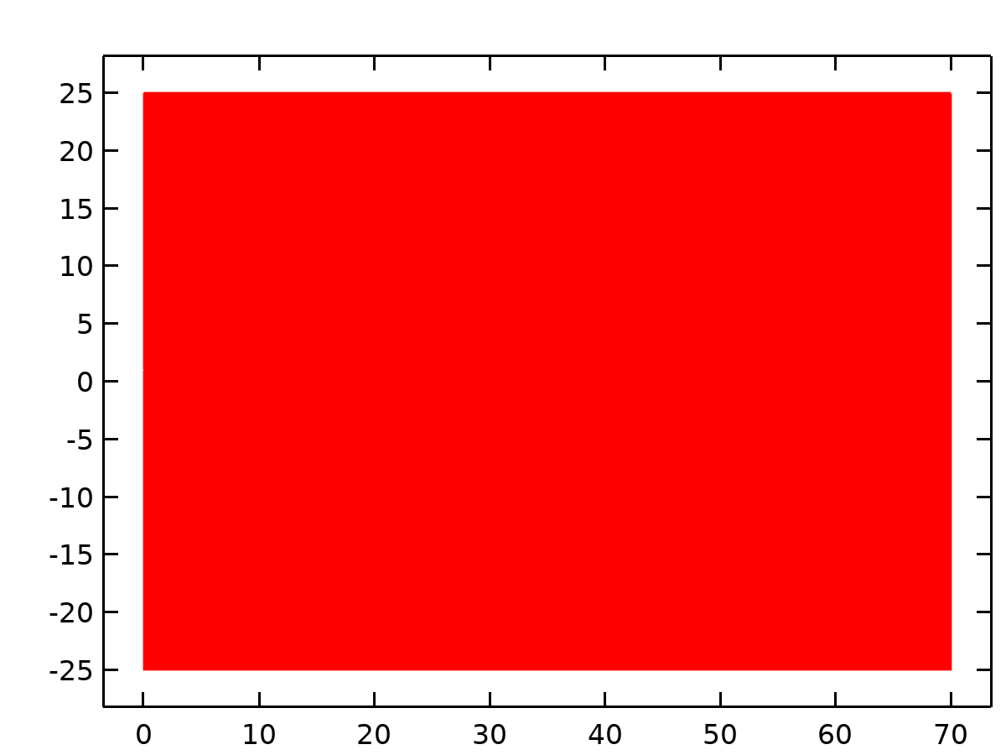

Dataset: Study 1/Solution 1

* + 1. Revolution 2D

Data

| **Description** | **Value** |
| --- | --- |
| Dataset | Study 1/Solution 1 |

Axis data

| **Description** | **Value** |
| --- | --- |
| Axis entry method | Two points |
| Points | {{0, 0}, {0, 1}} |

Revolution layers

| **Description** | **Value** |
| --- | --- |
| Start angle | -90 |
| Revolution angle | 225 |

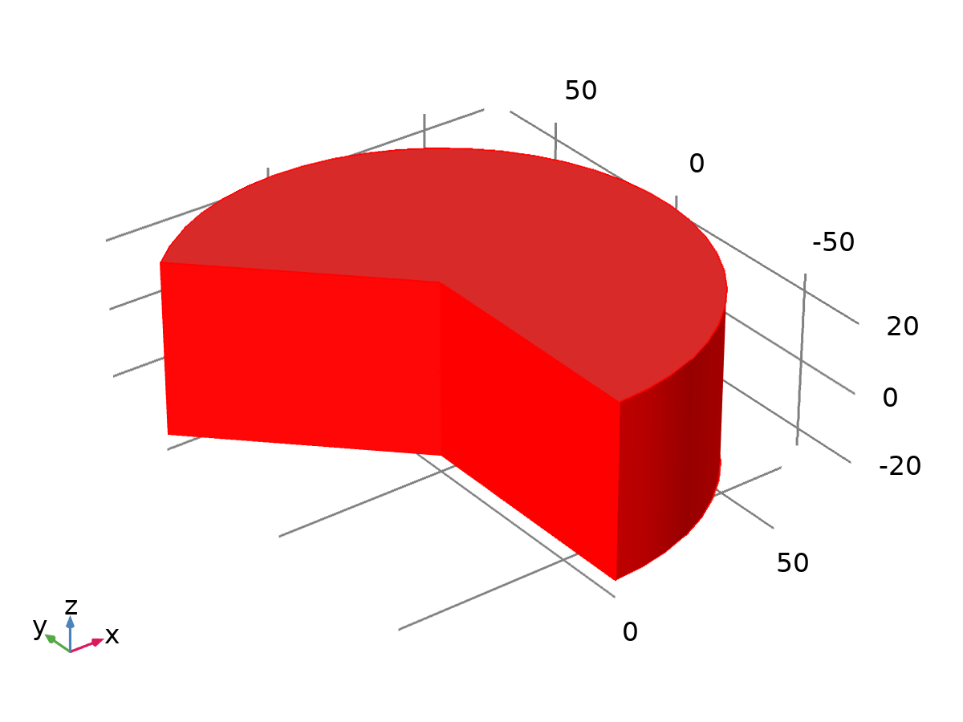

Dataset: Revolution 2D

* 1. Derived Values
     1. Line Integration 1

Output

|  |  |
| --- | --- |
| Evaluated in | Total Traction & Re Table |

Data

| **Description** | **Value** |
| --- | --- |
| Dataset | Study 1/Solution 1 |

Expressions

| **Expression** | **Unit** | **Description** |
| --- | --- | --- |
| spf.T_stressphi |  | Total traction, exterior boundaries, phi component |
| spf.T_stressr |  | Total traction, exterior boundaries, r component |
| spf.T_stressz |  | Total traction, exterior boundaries, z component |
|  |  |  |

Integration settings

| **Description** | **Value** |
| --- | --- |
| Integration order | 4 |
| Compute surface integral | On |

* 1. Tables
     1. Total Traction & Re Table

Line Integration 1

| **Re** | **Total traction, exterior boundaries, phi component** | **Total traction, exterior boundaries, r component** | **Total traction, exterior boundaries, z component** |
| --- | --- | --- | --- |
| 0.10000 | 0.0000 | -0.054954 | -21.338 |
| 0.20000 | 0.0000 | -0.25441 | -20.577 |
| 0.30000 | 0.0000 | -0.46773 | -20.523 |
| 0.40000 | 0.0000 | -0.68407 | -20.691 |
| 0.50000 | 0.0000 | -0.90035 | -20.935 |
| 0.60000 | 0.0000 | -1.1154 | -21.209 |
| 0.70000 | 0.0000 | -1.3288 | -21.493 |
| 0.80000 | 0.0000 | -1.5405 | -21.781 |
| 0.90000 | 0.0000 | -1.7505 | -22.070 |
| 1.0000 | 0.0000 | -1.9588 | -22.356 |
| 1.1000 | 0.0000 | -2.1657 | -22.639 |
| 1.2000 | 0.0000 | -2.3712 | -22.918 |
| 1.3000 | 0.0000 | -2.5754 | -23.194 |
| 1.4000 | 0.0000 | -2.7785 | -23.465 |
| 1.5000 | 0.0000 | -2.9805 | -23.732 |
| 1.6000 | 0.0000 | -3.1815 | -23.995 |
| 1.7000 | 0.0000 | -3.3816 | -24.254 |
| 1.8000 | 0.0000 | -3.5809 | -24.510 |
| 1.9000 | 0.0000 | -3.7794 | -24.761 |
| 2.0000 | 0.0000 | -3.9771 | -25.009 |
| 2.1000 | 0.0000 | -4.1742 | -25.254 |
| 2.2000 | 0.0000 | -4.3706 | -25.495 |
| 2.3000 | 0.0000 | -4.5664 | -25.732 |
| 2.4000 | 0.0000 | -4.7617 | -25.967 |
| 2.5000 | 0.0000 | -4.9565 | -26.199 |
| 2.6000 | 0.0000 | -5.1507 | -26.427 |
| 2.7000 | 0.0000 | -5.3446 | -26.653 |
| 2.8000 | 0.0000 | -5.5379 | -26.876 |
| 2.9000 | 0.0000 | -5.7309 | -27.097 |
| 3.0000 | 0.0000 | -5.9234 | -27.315 |
| 3.1000 | 0.0000 | -6.1156 | -27.530 |
| 3.2000 | 0.0000 | -6.3074 | -27.743 |
| 3.3000 | 0.0000 | -6.4989 | -27.954 |
| 3.4000 | 0.0000 | -6.6901 | -28.163 |
| 3.5000 | 0.0000 | -6.8810 | -28.369 |
| 3.6000 | 0.0000 | -7.0715 | -28.574 |
| 3.7000 | 0.0000 | -7.2618 | -28.776 |
| 3.8000 | 0.0000 | -7.4519 | -28.977 |
| 3.9000 | 0.0000 | -7.6416 | -29.175 |
| 4.0000 | 0.0000 | -7.8312 | -29.372 |
| 4.1000 | 0.0000 | -8.0205 | -29.567 |
| 4.2000 | 0.0000 | -8.2095 | -29.760 |
| 4.3000 | 0.0000 | -8.3984 | -29.952 |
| 4.4000 | 0.0000 | -8.5870 | -30.142 |
| 4.5000 | 0.0000 | -8.7754 | -30.330 |
| 4.6000 | 0.0000 | -8.9637 | -30.516 |
| 4.7000 | 0.0000 | -9.1517 | -30.702 |
| 4.8000 | 0.0000 | -9.3396 | -30.885 |
| 4.9000 | 0.0000 | -9.5273 | -31.068 |
| 5.0000 | 0.0000 | -9.7148 | -31.248 |
| 5.1000 | 0.0000 | -9.9022 | -31.428 |
| 5.2000 | 0.0000 | -10.089 | -31.606 |
| 5.3000 | 0.0000 | -10.276 | -31.783 |
| 5.4000 | 0.0000 | -10.463 | -31.958 |
| 5.5000 | 0.0000 | -10.650 | -32.132 |
| 5.6000 | 0.0000 | -10.837 | -32.305 |
| 5.7000 | 0.0000 | -11.023 | -32.477 |
| 5.8000 | 0.0000 | -11.209 | -32.648 |
| 5.9000 | 0.0000 | -11.396 | -32.817 |
| 6.0000 | 0.0000 | -11.582 | -32.986 |
| 6.1000 | 0.0000 | -11.768 | -33.153 |
| 6.2000 | 0.0000 | -11.953 | -33.319 |
| 6.3000 | 0.0000 | -12.139 | -33.484 |
| 6.4000 | 0.0000 | -12.325 | -33.649 |
| 6.5000 | 0.0000 | -12.510 | -33.812 |
| 6.6000 | 0.0000 | -12.695 | -33.974 |
| 6.7000 | 0.0000 | -12.881 | -34.135 |
| 6.8000 | 0.0000 | -13.066 | -34.295 |
| 6.9000 | 0.0000 | -13.251 | -34.454 |
| 7.0000 | 0.0000 | -13.436 | -34.613 |
| 7.1000 | 0.0000 | -13.620 | -34.770 |
| 7.2000 | 0.0000 | -13.805 | -34.926 |
| 7.3000 | 0.0000 | -13.990 | -35.082 |
| 7.4000 | 0.0000 | -14.174 | -35.237 |
| 7.5000 | 0.0000 | -14.359 | -35.391 |
| 7.6000 | 0.0000 | -14.543 | -35.544 |
| 7.7000 | 0.0000 | -14.727 | -35.696 |
| 7.8000 | 0.0000 | -14.912 | -35.848 |
| 7.9000 | 0.0000 | -15.095 | -35.999 |
| 8.0000 | 0.0000 | -15.279 | -36.149 |
| 8.1000 | 0.0000 | -15.463 | -36.298 |
| 8.2000 | 0.0000 | -15.647 | -36.446 |
| 8.3000 | 0.0000 | -15.831 | -36.594 |
| 8.4000 | 0.0000 | -16.014 | -36.741 |
| 8.5000 | 0.0000 | -16.198 | -36.887 |
| 8.6000 | 0.0000 | -16.381 | -37.033 |
| 8.7000 | 0.0000 | -16.565 | -37.178 |
| 8.8000 | 0.0000 | -16.748 | -37.322 |
| 8.9000 | 0.0000 | -16.931 | -37.465 |
| 9.0000 | 0.0000 | -17.114 | -37.608 |
| 9.1000 | 0.0000 | -17.297 | -37.750 |
| 9.2000 | 0.0000 | -17.481 | -37.892 |
| 9.3000 | 0.0000 | -17.664 | -38.033 |
| 9.4000 | 0.0000 | -17.847 | -38.173 |
| 9.5000 | 0.0000 | -18.029 | -38.313 |
| 9.6000 | 0.0000 | -18.212 | -38.452 |
| 9.7000 | 0.0000 | -18.395 | -38.590 |
| 9.8000 | 0.0000 | -18.577 | -38.728 |
| 9.9000 | 0.0000 | -18.760 | -38.866 |
| 10.000 | 0.0000 | -18.942 | -39.002 |
| 10.100 | 0.0000 | -19.125 | -39.138 |
| 10.200 | 0.0000 | -19.307 | -39.274 |
| 10.300 | 0.0000 | -19.489 | -39.409 |
| 10.400 | 0.0000 | -19.671 | -39.544 |
| 10.500 | 0.0000 | -19.853 | -39.678 |
| 10.600 | 0.0000 | -20.035 | -39.811 |
| 10.700 | 0.0000 | -20.217 | -39.944 |
| 10.800 | 0.0000 | -20.399 | -40.077 |
| 10.900 | 0.0000 | -20.581 | -40.209 |
| 11.000 | 0.0000 | -20.762 | -40.340 |
| 11.100 | 0.0000 | -20.944 | -40.471 |
| 11.200 | 0.0000 | -21.126 | -40.601 |
| 11.300 | 0.0000 | -21.309 | -40.731 |
| 11.400 | 0.0000 | -21.490 | -40.860 |
| 11.500 | 0.0000 | -21.671 | -40.990 |
| 11.600 | 0.0000 | -21.852 | -41.118 |
| 11.700 | 0.0000 | -22.033 | -41.246 |
| 11.800 | 0.0000 | -22.214 | -41.374 |
| 11.900 | 0.0000 | -22.395 | -41.501 |
| 12.000 | 0.0000 | -22.576 | -41.628 |
| 12.100 | 0.0000 | -22.757 | -41.754 |
| 12.200 | 0.0000 | -22.938 | -41.880 |
| 12.300 | 0.0000 | -23.119 | -42.005 |
| 12.400 | 0.0000 | -23.301 | -42.130 |
| 12.500 | 0.0000 | -23.481 | -42.255 |
| 12.600 | 0.0000 | -23.662 | -42.379 |
| 12.700 | 0.0000 | -23.842 | -42.503 |
| 12.800 | 0.0000 | -24.023 | -42.626 |
| 12.900 | 0.0000 | -24.203 | -42.749 |
| 13.000 | 0.0000 | -24.383 | -42.872 |
| 13.100 | 0.0000 | -24.563 | -42.994 |
| 13.200 | 0.0000 | -24.743 | -43.116 |
| 13.300 | 0.0000 | -24.923 | -43.237 |
| 13.400 | 0.0000 | -25.103 | -43.358 |
| 13.500 | 0.0000 | -25.283 | -43.479 |
| 13.600 | 0.0000 | -25.463 | -43.599 |
| 13.700 | 0.0000 | -25.643 | -43.719 |
| 13.800 | 0.0000 | -25.822 | -43.838 |
| 13.900 | 0.0000 | -26.002 | -43.958 |
| 14.000 | 0.0000 | -26.181 | -44.076 |
| 14.100 | 0.0000 | -26.361 | -44.195 |
| 14.200 | 0.0000 | -26.542 | -44.313 |
| 14.300 | 0.0000 | -26.721 | -44.430 |
| 14.400 | 0.0000 | -26.900 | -44.548 |
| 14.500 | 0.0000 | -27.080 | -44.665 |
| 14.600 | 0.0000 | -27.259 | -44.782 |
| 14.700 | 0.0000 | -27.438 | -44.898 |
| 14.800 | 0.0000 | -27.617 | -45.014 |
| 14.900 | 0.0000 | -27.796 | -45.130 |
| 15.000 | 0.0000 | -27.975 | -45.245 |
| 15.100 | 0.0000 | -28.154 | -45.360 |
| 15.200 | 0.0000 | -28.332 | -45.475 |
| 15.300 | 0.0000 | -28.511 | -45.590 |
| 15.400 | 0.0000 | -28.690 | -45.704 |
| 15.500 | 0.0000 | -28.868 | -45.818 |
| 15.600 | 0.0000 | -29.047 | -45.931 |
| 15.700 | 0.0000 | -29.225 | -46.045 |
| 15.800 | 0.0000 | -29.404 | -46.158 |
| 15.900 | 0.0000 | -29.582 | -46.270 |
| 16.000 | 0.0000 | -29.760 | -46.383 |
| 16.100 | 0.0000 | -29.938 | -46.495 |
| 16.200 | 0.0000 | -30.116 | -46.606 |
| 16.300 | 0.0000 | -30.294 | -46.718 |
| 16.400 | 0.0000 | -30.473 | -46.829 |
| 16.500 | 0.0000 | -30.651 | -46.940 |
| 16.600 | 0.0000 | -30.829 | -47.051 |
| 16.700 | 0.0000 | -31.006 | -47.161 |
| 16.800 | 0.0000 | -31.184 | -47.271 |
| 16.900 | 0.0000 | -31.362 | -47.381 |
| 17.000 | 0.0000 | -31.539 | -47.490 |
| 17.100 | 0.0000 | -31.717 | -47.600 |
| 17.200 | 0.0000 | -31.894 | -47.709 |
| 17.300 | 0.0000 | -32.071 | -47.817 |
| 17.400 | 0.0000 | -32.249 | -47.926 |
| 17.500 | 0.0000 | -32.426 | -48.034 |
| 17.600 | 0.0000 | -32.603 | -48.142 |
| 17.700 | 0.0000 | -32.780 | -48.250 |
| 17.800 | 0.0000 | -32.957 | -48.357 |
| 17.900 | 0.0000 | -33.134 | -48.465 |
| 18.000 | 0.0000 | -33.311 | -48.572 |
| 18.100 | 0.0000 | -33.488 | -48.678 |
| 18.200 | 0.0000 | -33.665 | -48.785 |
| 18.300 | 0.0000 | -33.842 | -48.891 |
| 18.400 | 0.0000 | -34.018 | -48.997 |
| 18.500 | 0.0000 | -34.195 | -49.103 |
| 18.600 | 0.0000 | -34.371 | -49.208 |
| 18.700 | 0.0000 | -34.548 | -49.314 |
| 18.800 | 0.0000 | -34.724 | -49.419 |
| 18.900 | 0.0000 | -34.900 | -49.524 |
| 19.000 | 0.0000 | -35.077 | -49.628 |
| 19.100 | 0.0000 | -35.253 | -49.733 |
| 19.200 | 0.0000 | -35.429 | -49.837 |
| 19.300 | 0.0000 | -35.605 | -49.941 |
| 19.400 | 0.0000 | -35.781 | -50.045 |
| 19.500 | 0.0000 | -35.957 | -50.148 |
| 19.600 | 0.0000 | -36.133 | -50.252 |
| 19.700 | 0.0000 | -36.309 | -50.355 |
| 19.800 | 0.0000 | -36.484 | -50.458 |
| 19.900 | 0.0000 | -36.660 | -50.560 |
| 20.000 | 0.0000 | -36.835 | -50.663 |
| 20.100 | 0.0000 | -37.011 | -50.765 |
| 20.200 | 0.0000 | -37.186 | -50.867 |
| 20.300 | 0.0000 | -37.361 | -50.969 |
| 20.400 | 0.0000 | -37.536 | -51.071 |
| 20.500 | 0.0000 | -37.712 | -51.172 |
| 20.600 | 0.0000 | -37.887 | -51.273 |
| 20.700 | 0.0000 | -38.062 | -51.374 |
| 20.800 | 0.0000 | -38.237 | -51.475 |
| 20.900 | 0.0000 | -38.411 | -51.576 |
| 21.000 | 0.0000 | -38.586 | -51.676 |
| 21.100 | 0.0000 | -38.759 | -51.777 |
| 21.200 | 0.0000 | -38.934 | -51.877 |
| 21.300 | 0.0000 | -39.108 | -51.977 |
| 21.400 | 0.0000 | -39.283 | -52.077 |
| 21.500 | 0.0000 | -39.457 | -52.176 |
| 21.600 | 0.0000 | -39.632 | -52.276 |
| 21.700 | 0.0000 | -39.806 | -52.375 |
| 21.800 | 0.0000 | -39.980 | -52.474 |
| 21.900 | 0.0000 | -40.155 | -52.572 |
| 22.000 | 0.0000 | -40.329 | -52.671 |
| 22.100 | 0.0000 | -40.503 | -52.769 |
| 22.200 | 0.0000 | -40.678 | -52.867 |
| 22.300 | 0.0000 | -40.852 | -52.965 |
| 22.400 | 0.0000 | -41.026 | -53.063 |
| 22.500 | 0.0000 | -41.200 | -53.161 |
| 22.600 | 0.0000 | -41.374 | -53.258 |
| 22.700 | 0.0000 | -41.547 | -53.356 |
| 22.800 | 0.0000 | -41.721 | -53.453 |
| 22.900 | 0.0000 | -41.895 | -53.550 |
| 23.000 | 0.0000 | -42.068 | -53.647 |
| 23.100 | 0.0000 | -42.241 | -53.743 |
| 23.200 | 0.0000 | -42.415 | -53.840 |
| 23.300 | 0.0000 | -42.588 | -53.936 |
| 23.400 | 0.0000 | -42.761 | -54.032 |
| 23.500 | 0.0000 | -42.934 | -54.128 |
| 23.600 | 0.0000 | -43.107 | -54.224 |
| 23.700 | 0.0000 | -43.280 | -54.320 |
| 23.800 | 0.0000 | -43.453 | -54.415 |
| 23.900 | 0.0000 | -43.626 | -54.511 |
| 24.000 | 0.0000 | -43.799 | -54.606 |
| 24.100 | 0.0000 | -43.971 | -54.701 |
| 24.200 | 0.0000 | -44.144 | -54.796 |
| 24.300 | 0.0000 | -44.316 | -54.890 |
| 24.400 | 0.0000 | -44.489 | -54.985 |
| 24.500 | 0.0000 | -44.661 | -55.079 |
| 24.600 | 0.0000 | -44.833 | -55.174 |
| 24.700 | 0.0000 | -45.005 | -55.268 |
| 24.800 | 0.0000 | -45.178 | -55.362 |
| 24.900 | 0.0000 | -45.350 | -55.455 |
| 25.000 | 0.0000 | -45.522 | -55.549 |
| 25.100 | 0.0000 | -45.694 | -55.643 |
| 25.200 | 0.0000 | -45.865 | -55.736 |
| 25.300 | 0.0000 | -46.035 | -55.830 |
| 25.400 | 0.0000 | -46.207 | -55.923 |
| 25.500 | 0.0000 | -46.378 | -56.016 |
| 25.600 | 0.0000 | -46.550 | -56.108 |
| 25.700 | 0.0000 | -46.721 | -56.201 |
| 25.800 | 0.0000 | -46.893 | -56.294 |
| 25.900 | 0.0000 | -47.064 | -56.386 |
| 26.000 | 0.0000 | -47.235 | -56.478 |
| 26.100 | 0.0000 | -47.407 | -56.570 |
| 26.200 | 0.0000 | -47.578 | -56.662 |
| 26.300 | 0.0000 | -47.749 | -56.754 |
| 26.400 | 0.0000 | -47.920 | -56.846 |
| 26.500 | 0.0000 | -48.091 | -56.938 |
| 26.600 | 0.0000 | -48.262 | -57.029 |
| 26.700 | 0.0000 | -48.432 | -57.120 |
| 26.800 | 0.0000 | -48.603 | -57.212 |
| 26.900 | 0.0000 | -48.774 | -57.303 |
| 27.000 | 0.0000 | -48.944 | -57.394 |
| 27.100 | 0.0000 | -49.114 | -57.484 |
| 27.200 | 0.0000 | -49.285 | -57.575 |
| 27.300 | 0.0000 | -49.455 | -57.666 |
| 27.400 | 0.0000 | -49.625 | -57.756 |
| 27.500 | 0.0000 | -49.795 | -57.847 |
| 27.600 | 0.0000 | -49.966 | -57.937 |
| 27.700 | 0.0000 | -50.136 | -58.027 |
| 27.800 | 0.0000 | -50.305 | -58.117 |
| 27.900 | 0.0000 | -50.475 | -58.207 |
| 28.000 | 0.0000 | -50.645 | -58.296 |
| 28.100 | 0.0000 | -50.815 | -58.386 |
| 28.200 | 0.0000 | -50.984 | -58.476 |
| 28.300 | 0.0000 | -51.154 | -58.565 |
| 28.400 | 0.0000 | -51.323 | -58.654 |
| 28.500 | 0.0000 | -51.492 | -58.744 |
| 28.600 | 0.0000 | -51.661 | -58.833 |
| 28.700 | 0.0000 | -51.831 | -58.922 |
| 28.800 | 0.0000 | -52.000 | -59.010 |
| 28.900 | 0.0000 | -52.169 | -59.099 |
| 29.000 | 0.0000 | -52.338 | -59.188 |
| 29.100 | 0.0000 | -52.507 | -59.276 |
| 29.200 | 0.0000 | -52.676 | -59.365 |
| 29.300 | 0.0000 | -52.844 | -59.453 |
| 29.400 | 0.0000 | -53.013 | -59.541 |
| 29.500 | 0.0000 | -53.181 | -59.629 |
| 29.600 | 0.0000 | -53.350 | -59.717 |
| 29.700 | 0.0000 | -53.518 | -59.805 |
| 29.800 | 0.0000 | -53.687 | -59.893 |
| 29.900 | 0.0000 | -53.855 | -59.981 |
| 30.000 | 0.0000 | -54.023 | -60.068 |
| 30.100 | 0.0000 | -54.191 | -60.156 |
| 30.200 | 0.0000 | -54.359 | -60.243 |
| 30.300 | 0.0000 | -54.527 | -60.330 |
| 30.400 | 0.0000 | -54.695 | -60.418 |
| 30.500 | 0.0000 | -54.863 | -60.505 |
| 30.600 | 0.0000 | -55.030 | -60.592 |
| 30.700 | 0.0000 | -55.198 | -60.678 |
| 30.800 | 0.0000 | -55.366 | -60.765 |
| 30.900 | 0.0000 | -55.533 | -60.852 |
| 31.000 | 0.0000 | -55.701 | -60.938 |
| 31.100 | 0.0000 | -55.868 | -61.025 |
| 31.200 | 0.0000 | -56.035 | -61.111 |
| 31.300 | 0.0000 | -56.202 | -61.197 |
| 31.400 | 0.0000 | -56.369 | -61.284 |
| 31.500 | 0.0000 | -56.536 | -61.370 |
| 31.600 | 0.0000 | -56.703 | -61.456 |
| 31.700 | 0.0000 | -56.870 | -61.541 |
| 31.800 | 0.0000 | -57.037 | -61.627 |
| 31.900 | 0.0000 | -57.204 | -61.713 |
| 32.000 | 0.0000 | -57.370 | -61.799 |
| 32.100 | 0.0000 | -57.537 | -61.884 |
| 32.200 | 0.0000 | -57.703 | -61.969 |
| 32.300 | 0.0000 | -57.870 | -62.055 |
| 32.400 | 0.0000 | -58.036 | -62.140 |
| 32.500 | 0.0000 | -58.202 | -62.225 |
| 32.600 | 0.0000 | -58.368 | -62.310 |
| 32.700 | 0.0000 | -58.535 | -62.395 |
| 32.800 | 0.0000 | -58.701 | -62.480 |
| 32.900 | 0.0000 | -58.867 | -62.565 |
| 33.000 | 0.0000 | -59.032 | -62.649 |
| 33.100 | 0.0000 | -59.198 | -62.734 |
| 33.200 | 0.0000 | -59.364 | -62.819 |
| 33.300 | 0.0000 | -59.529 | -62.903 |
| 33.400 | 0.0000 | -59.695 | -62.987 |
| 33.500 | 0.0000 | -59.860 | -63.072 |
| 33.600 | 0.0000 | -60.026 | -63.156 |
| 33.700 | 0.0000 | -60.191 | -63.240 |
| 33.800 | 0.0000 | -60.356 | -63.324 |
| 33.900 | 0.0000 | -60.521 | -63.408 |
| 34.000 | 0.0000 | -60.686 | -63.492 |
| 34.100 | 0.0000 | -60.851 | -63.576 |
| 34.200 | 0.0000 | -61.015 | -63.659 |
| 34.300 | 0.0000 | -61.180 | -63.743 |
| 34.400 | 0.0000 | -61.345 | -63.826 |
| 34.500 | 0.0000 | -61.509 | -63.910 |
| 34.600 | 0.0000 | -61.673 | -63.993 |
| 34.700 | 0.0000 | -61.838 | -64.076 |
| 34.800 | 0.0000 | -62.002 | -64.160 |
| 34.900 | 0.0000 | -62.166 | -64.243 |
| 35.000 | 0.0000 | -62.330 | -64.326 |
| 35.100 | 0.0000 | -62.494 | -64.409 |
| 35.200 | 0.0000 | -62.658 | -64.492 |
| 35.300 | 0.0000 | -62.822 | -64.575 |
| 35.400 | 0.0000 | -62.986 | -64.657 |
| 35.500 | 0.0000 | -63.149 | -64.740 |
| 35.600 | 0.0000 | -63.313 | -64.823 |
| 35.700 | 0.0000 | -63.476 | -64.905 |
| 35.800 | 0.0000 | -63.640 | -64.988 |
| 35.900 | 0.0000 | -63.803 | -65.070 |
| 36.000 | 0.0000 | -63.966 | -65.152 |
| 36.100 | 0.0000 | -64.129 | -65.235 |
| 36.200 | 0.0000 | -64.292 | -65.317 |
| 36.300 | 0.0000 | -64.455 | -65.399 |
| 36.400 | 0.0000 | -64.618 | -65.481 |
| 36.500 | 0.0000 | -64.781 | -65.563 |
| 36.600 | 0.0000 | -64.943 | -65.645 |
| 36.700 | 0.0000 | -65.106 | -65.727 |
| 36.800 | 0.0000 | -65.268 | -65.809 |
| 36.900 | 0.0000 | -65.430 | -65.890 |
| 37.000 | 0.0000 | -65.593 | -65.972 |
| 37.100 | 0.0000 | -65.755 | -66.054 |
| 37.200 | 0.0000 | -65.917 | -66.135 |
| 37.300 | 0.0000 | -66.079 | -66.217 |
| 37.400 | 0.0000 | -66.241 | -66.298 |
| 37.500 | 0.0000 | -66.403 | -66.379 |
| 37.600 | 0.0000 | -66.565 | -66.461 |
| 37.700 | 0.0000 | -66.726 | -66.542 |
| 37.800 | 0.0000 | -66.888 | -66.623 |
| 37.900 | 0.0000 | -67.049 | -66.704 |
| 38.000 | 0.0000 | -67.211 | -66.785 |
| 38.100 | 0.0000 | -67.372 | -66.866 |
| 38.200 | 0.0000 | -67.533 | -66.947 |
| 38.300 | 0.0000 | -67.695 | -67.027 |
| 38.400 | 0.0000 | -67.856 | -67.108 |
| 38.500 | 0.0000 | -68.017 | -67.189 |
| 38.600 | 0.0000 | -68.178 | -67.269 |
| 38.700 | 0.0000 | -68.339 | -67.350 |
| 38.800 | 0.0000 | -68.499 | -67.430 |
| 38.900 | 0.0000 | -68.660 | -67.511 |
| 39.000 | 0.0000 | -68.821 | -67.591 |
| 39.100 | 0.0000 | -68.981 | -67.671 |
| 39.200 | 0.0000 | -69.142 | -67.752 |
| 39.300 | 0.0000 | -69.302 | -67.832 |
| 39.400 | 0.0000 | -69.462 | -67.912 |
| 39.500 | 0.0000 | -69.622 | -67.992 |
| 39.600 | 0.0000 | -69.782 | -68.072 |
| 39.700 | 0.0000 | -69.942 | -68.152 |
| 39.800 | 0.0000 | -70.102 | -68.232 |
| 39.900 | 0.0000 | -70.262 | -68.312 |
| 40.000 | 0.0000 | -70.421 | -68.392 |
| 40.100 | 0.0000 | -70.581 | -68.472 |
| 40.200 | 0.0000 | -70.740 | -68.551 |
| 40.300 | 0.0000 | -70.900 | -68.631 |
| 40.400 | 0.0000 | -71.059 | -68.711 |
| 40.500 | 0.0000 | -71.218 | -68.790 |
| 40.600 | 0.0000 | -71.377 | -68.870 |
| 40.700 | 0.0000 | -71.536 | -68.949 |
| 40.800 | 0.0000 | -71.695 | -69.028 |
| 40.900 | 0.0000 | -71.853 | -69.108 |
| 41.000 | 0.0000 | -72.012 | -69.187 |
| 41.100 | 0.0000 | -72.170 | -69.266 |
| 41.200 | 0.0000 | -72.329 | -69.345 |
| 41.300 | 0.0000 | -72.487 | -69.425 |
| 41.400 | 0.0000 | -72.645 | -69.504 |
| 41.500 | 0.0000 | -72.803 | -69.582 |
| 41.600 | 0.0000 | -72.961 | -69.661 |
| 41.700 | 0.0000 | -73.119 | -69.740 |
| 41.800 | 0.0000 | -73.277 | -69.819 |
| 41.900 | 0.0000 | -73.434 | -69.898 |
| 42.000 | 0.0000 | -73.591 | -69.977 |
| 42.100 | 0.0000 | -73.749 | -70.055 |
| 42.200 | 0.0000 | -73.906 | -70.134 |
| 42.300 | 0.0000 | -74.063 | -70.213 |
| 42.400 | 0.0000 | -74.220 | -70.291 |
| 42.500 | 0.0000 | -74.377 | -70.370 |
| 42.600 | 0.0000 | -74.534 | -70.448 |
| 42.700 | 0.0000 | -74.690 | -70.527 |
| 42.800 | 0.0000 | -74.847 | -70.605 |
| 42.900 | 0.0000 | -75.004 | -70.683 |
| 43.000 | 0.0000 | -75.159 | -70.762 |
| 43.100 | 0.0000 | -75.316 | -70.840 |
| 43.200 | 0.0000 | -75.472 | -70.918 |
| 43.300 | 0.0000 | -75.628 | -70.996 |
| 43.400 | 0.0000 | -75.784 | -71.074 |
| 43.500 | 0.0000 | -75.940 | -71.152 |
| 43.600 | 0.0000 | -76.097 | -71.230 |
| 43.700 | 0.0000 | -76.252 | -71.308 |
| 43.800 | 0.0000 | -76.408 | -71.386 |
| 43.900 | 0.0000 | -76.564 | -71.464 |
| 44.000 | 0.0000 | -76.719 | -71.541 |
| 44.100 | 0.0000 | -76.875 | -71.619 |
| 44.200 | 0.0000 | -77.030 | -71.697 |
| 44.300 | 0.0000 | -77.185 | -71.774 |
| 44.400 | 0.0000 | -77.340 | -71.852 |
| 44.500 | 0.0000 | -77.495 | -71.929 |
| 44.600 | 0.0000 | -77.650 | -72.007 |
| 44.700 | 0.0000 | -77.805 | -72.084 |
| 44.800 | 0.0000 | -77.959 | -72.162 |
| 44.900 | 0.0000 | -78.114 | -72.239 |
| 45.000 | 0.0000 | -78.268 | -72.317 |
| 45.100 | 0.0000 | -78.422 | -72.394 |
| 45.200 | 0.0000 | -78.577 | -72.471 |
| 45.300 | 0.0000 | -78.731 | -72.549 |
| 45.400 | 0.0000 | -78.885 | -72.626 |
| 45.500 | 0.0000 | -79.038 | -72.704 |
| 45.600 | 0.0000 | -79.192 | -72.781 |
| 45.700 | 0.0000 | -79.346 | -72.858 |
| 45.800 | 0.0000 | -79.500 | -72.935 |
| 45.900 | 0.0000 | -79.653 | -73.012 |
| 46.000 | 0.0000 | -79.807 | -73.089 |
| 46.100 | 0.0000 | -79.960 | -73.166 |
| 46.200 | 0.0000 | -80.112 | -73.243 |
| 46.300 | 0.0000 | -80.265 | -73.320 |
| 46.400 | 0.0000 | -80.417 | -73.397 |
| 46.500 | 0.0000 | -80.570 | -73.474 |
| 46.600 | 0.0000 | -80.723 | -73.551 |
| 46.700 | 0.0000 | -80.875 | -73.628 |
| 46.800 | 0.0000 | -81.028 | -73.704 |
| 46.900 | 0.0000 | -81.181 | -73.781 |
| 47.000 | 0.0000 | -81.333 | -73.858 |
| 47.100 | 0.0000 | -81.485 | -73.935 |
| 47.200 | 0.0000 | -81.637 | -74.011 |
| 47.300 | 0.0000 | -81.789 | -74.088 |
| 47.400 | 0.0000 | -81.941 | -74.164 |
| 47.500 | 0.0000 | -82.093 | -74.240 |
| 47.600 | 0.0000 | -82.245 | -74.317 |
| 47.700 | 0.0000 | -82.396 | -74.393 |
| 47.800 | 0.0000 | -82.548 | -74.469 |
| 47.900 | 0.0000 | -82.700 | -74.546 |
| 48.000 | 0.0000 | -82.851 | -74.622 |
| 48.100 | 0.0000 | -83.002 | -74.698 |
| 48.200 | 0.0000 | -83.153 | -74.774 |
| 48.300 | 0.0000 | -83.304 | -74.850 |
| 48.400 | 0.0000 | -83.455 | -74.926 |
| 48.500 | 0.0000 | -83.606 | -75.002 |
| 48.600 | 0.0000 | -83.756 | -75.078 |
| 48.700 | 0.0000 | -83.907 | -75.154 |
| 48.800 | 0.0000 | -84.058 | -75.230 |
| 48.900 | 0.0000 | -84.208 | -75.306 |
| 49.000 | 0.0000 | -84.358 | -75.382 |
| 49.100 | 0.0000 | -84.507 | -75.458 |
| 49.200 | 0.0000 | -84.657 | -75.534 |
| 49.300 | 0.0000 | -84.807 | -75.609 |
| 49.400 | 0.0000 | -84.957 | -75.685 |
| 49.500 | 0.0000 | -85.107 | -75.760 |
| 49.600 | 0.0000 | -85.257 | -75.836 |
| 49.700 | 0.0000 | -85.407 | -75.911 |
| 49.800 | 0.0000 | -85.556 | -75.987 |
| 49.900 | 0.0000 | -85.705 | -76.062 |
| 50.000 | 0.0000 | -85.854 | -76.138 |
| 50.100 | 0.0000 | -86.003 | -76.214 |
| 50.200 | 0.0000 | -86.151 | -76.289 |
| 50.300 | 0.0000 | -86.300 | -76.365 |
| 50.400 | 0.0000 | -86.449 | -76.440 |
| 50.500 | 0.0000 | -86.598 | -76.515 |
| 50.600 | 0.0000 | -86.746 | -76.590 |
| 50.700 | 0.0000 | -86.894 | -76.666 |
| 50.800 | 0.0000 | -87.043 | -76.741 |
| 50.900 | 0.0000 | -87.191 | -76.816 |
| 51.000 | 0.0000 | -87.339 | -76.891 |
| 51.100 | 0.0000 | -87.487 | -76.966 |
| 51.200 | 0.0000 | -87.635 | -77.041 |
| 51.300 | 0.0000 | -87.783 | -77.116 |
| 51.400 | 0.0000 | -87.930 | -77.191 |
| 51.500 | 0.0000 | -88.078 | -77.266 |
| 51.600 | 0.0000 | -88.225 | -77.341 |
| 51.700 | 0.0000 | -88.373 | -77.416 |
| 51.800 | 0.0000 | -88.520 | -77.491 |
| 51.900 | 0.0000 | -88.667 | -77.565 |
| 52.000 | 0.0000 | -88.814 | -77.640 |
| 52.100 | 0.0000 | -88.962 | -77.715 |
| 52.200 | 0.0000 | -89.109 | -77.789 |
| 52.300 | 0.0000 | -89.255 | -77.864 |
| 52.400 | 0.0000 | -89.402 | -77.939 |
| 52.500 | 0.0000 | -89.548 | -78.014 |
| 52.600 | 0.0000 | -89.694 | -78.088 |
| 52.700 | 0.0000 | -89.840 | -78.163 |
| 52.800 | 0.0000 | -89.985 | -78.238 |
| 52.900 | 0.0000 | -90.131 | -78.312 |
| 53.000 | 0.0000 | -90.277 | -78.387 |
| 53.100 | 0.0000 | -90.422 | -78.461 |
| 53.200 | 0.0000 | -90.567 | -78.536 |
| 53.300 | 0.0000 | -90.712 | -78.610 |
| 53.400 | 0.0000 | -90.857 | -78.685 |
| 53.500 | 0.0000 | -91.002 | -78.759 |
| 53.600 | 0.0000 | -91.148 | -78.834 |
| 53.700 | 0.0000 | -91.293 | -78.908 |
| 53.800 | 0.0000 | -91.437 | -78.982 |
| 53.900 | 0.0000 | -91.581 | -79.057 |
| 54.000 | 0.0000 | -91.725 | -79.131 |
| 54.100 | 0.0000 | -91.870 | -79.205 |
| 54.200 | 0.0000 | -92.014 | -79.279 |
| 54.300 | 0.0000 | -92.158 | -79.354 |
| 54.400 | 0.0000 | -92.302 | -79.428 |
| 54.500 | 0.0000 | -92.446 | -79.502 |
| 54.600 | 0.0000 | -92.590 | -79.576 |
| 54.700 | 0.0000 | -92.733 | -79.650 |
| 54.800 | 0.0000 | -92.877 | -79.724 |
| 54.900 | 0.0000 | -93.022 | -79.799 |
| 55.000 | 0.0000 | -93.166 | -79.873 |
| 55.100 | 0.0000 | -93.309 | -79.947 |
| 55.200 | 0.0000 | -93.452 | -80.021 |
| 55.300 | 0.0000 | -93.595 | -80.095 |
| 55.400 | 0.0000 | -93.738 | -80.169 |
| 55.500 | 0.0000 | -93.881 | -80.243 |
| 55.600 | 0.0000 | -94.024 | -80.317 |
| 55.700 | 0.0000 | -94.167 | -80.391 |
| 55.800 | 0.0000 | -94.310 | -80.465 |
| 55.900 | 0.0000 | -94.452 | -80.539 |
| 56.000 | 0.0000 | -94.593 | -80.614 |
| 56.100 | 0.0000 | -94.733 | -80.688 |
| 56.200 | 0.0000 | -94.876 | -80.762 |
| 56.300 | 0.0000 | -95.018 | -80.835 |
| 56.400 | 0.0000 | -95.160 | -80.909 |
| 56.500 | 0.0000 | -95.302 | -80.982 |
| 56.600 | 0.0000 | -95.443 | -81.056 |
| 56.700 | 0.0000 | -95.584 | -81.130 |
| 56.800 | 0.0000 | -95.725 | -81.204 |
| 56.900 | 0.0000 | -95.866 | -81.278 |
| 57.000 | 0.0000 | -96.007 | -81.351 |
| 57.100 | 0.0000 | -96.148 | -81.424 |
| 57.200 | 0.0000 | -96.289 | -81.498 |
| 57.300 | 0.0000 | -96.430 | -81.571 |
| 57.400 | 0.0000 | -96.570 | -81.645 |
| 57.500 | 0.0000 | -96.710 | -81.719 |
| 57.600 | 0.0000 | -96.851 | -81.792 |
| 57.700 | 0.0000 | -96.991 | -81.865 |
| 57.800 | 0.0000 | -97.131 | -81.939 |
| 57.900 | 0.0000 | -97.271 | -82.012 |
| 58.000 | 0.0000 | -97.410 | -82.085 |
| 58.100 | 0.0000 | -97.550 | -82.159 |
| 58.200 | 0.0000 | -97.689 | -82.232 |
| 58.300 | 0.0000 | -97.829 | -82.305 |
| 58.400 | 0.0000 | -97.968 | -82.378 |
| 58.500 | 0.0000 | -98.107 | -82.451 |
| 58.600 | 0.0000 | -98.247 | -82.524 |
| 58.700 | 0.0000 | -98.386 | -82.597 |
| 58.800 | 0.0000 | -98.525 | -82.670 |
| 58.900 | 0.0000 | -98.664 | -82.743 |
| 59.000 | 0.0000 | -98.804 | -82.815 |
| 59.100 | 0.0000 | -98.942 | -82.889 |
| 59.200 | 0.0000 | -99.081 | -82.961 |
| 59.300 | 0.0000 | -99.219 | -83.034 |
| 59.400 | 0.0000 | -99.357 | -83.107 |
| 59.500 | 0.0000 | -99.495 | -83.180 |
| 59.600 | 0.0000 | -99.633 | -83.254 |
| 59.700 | 0.0000 | -99.771 | -83.326 |
| 59.800 | 0.0000 | -99.909 | -83.399 |
| 59.900 | 0.0000 | -100.05 | -83.472 |
| 60.000 | 0.0000 | -100.18 | -83.545 |
| 60.100 | 0.0000 | -100.32 | -83.618 |
| 60.200 | 0.0000 | -100.46 | -83.691 |
| 60.300 | 0.0000 | -100.59 | -83.763 |
| 60.400 | 0.0000 | -100.73 | -83.836 |
| 60.500 | 0.0000 | -100.87 | -83.909 |
| 60.600 | 0.0000 | -101.00 | -83.981 |
| 60.700 | 0.0000 | -101.14 | -84.054 |
| 60.800 | 0.0000 | -101.28 | -84.126 |
| 60.900 | 0.0000 | -101.41 | -84.199 |
| 61.000 | 0.0000 | -101.55 | -84.271 |
| 61.100 | 0.0000 | -101.69 | -84.344 |
| 61.200 | 0.0000 | -101.82 | -84.417 |
| 61.300 | 0.0000 | -101.96 | -84.489 |
| 61.400 | 0.0000 | -102.09 | -84.562 |
| 61.500 | 0.0000 | -102.23 | -84.634 |
| 61.600 | 0.0000 | -102.37 | -84.707 |
| 61.700 | 0.0000 | -102.50 | -84.780 |
| 61.800 | 0.0000 | -102.64 | -84.854 |
| 61.900 | 0.0000 | -102.77 | -84.926 |
| 62.000 | 0.0000 | -102.91 | -84.999 |
| 62.100 | 0.0000 | -103.04 | -85.071 |
| 62.200 | 0.0000 | -103.18 | -85.143 |
| 62.300 | 0.0000 | -103.31 | -85.216 |
| 62.400 | 0.0000 | -103.45 | -85.288 |
| 62.500 | 0.0000 | -103.58 | -85.360 |
| 62.600 | 0.0000 | -103.71 | -85.432 |
| 62.700 | 0.0000 | -103.85 | -85.505 |
| 62.800 | 0.0000 | -103.98 | -85.577 |
| 62.900 | 0.0000 | -104.12 | -85.650 |
| 63.000 | 0.0000 | -104.25 | -85.722 |
| 63.100 | 0.0000 | -104.38 | -85.794 |
| 63.200 | 0.0000 | -104.52 | -85.866 |
| 63.300 | 0.0000 | -104.65 | -85.939 |
| 63.400 | 0.0000 | -104.78 | -86.011 |
| 63.500 | 0.0000 | -104.92 | -86.084 |
| 63.600 | 0.0000 | -105.05 | -86.156 |
| 63.700 | 0.0000 | -105.18 | -86.228 |
| 63.800 | 0.0000 | -105.31 | -86.300 |
| 63.900 | 0.0000 | -105.45 | -86.372 |
| 64.000 | 0.0000 | -105.58 | -86.445 |
| 64.100 | 0.0000 | -105.71 | -86.518 |
| 64.200 | 0.0000 | -105.84 | -86.590 |
| 64.300 | 0.0000 | -105.97 | -86.662 |
| 64.400 | 0.0000 | -106.10 | -86.735 |
| 64.500 | 0.0000 | -106.24 | -86.807 |
| 64.600 | 0.0000 | -106.37 | -86.880 |
| 64.700 | 0.0000 | -106.50 | -86.953 |
| 64.800 | 0.0000 | -106.63 | -87.026 |
| 64.900 | 0.0000 | -106.76 | -87.100 |
| 65.000 | 0.0000 | -106.89 | -87.174 |
| 65.100 | 0.0000 | -107.02 | -87.244 |
| 65.200 | 0.0000 | -107.12 | -87.307 |
| 65.300 | 0.0000 | -107.25 | -87.380 |
| 65.400 | 0.0000 | -107.38 | -87.453 |
| 65.500 | 0.0000 | -107.51 | -87.524 |
| 65.600 | 0.0000 | -107.65 | -87.597 |
| 65.700 | 0.0000 | -107.78 | -87.668 |
| 65.800 | 0.0000 | -107.90 | -87.734 |
| 65.900 | 0.0000 | -108.02 | -87.802 |
| 66.000 | 0.0000 | -108.15 | -87.874 |
| 66.100 | 0.0000 | -108.28 | -87.945 |
| 66.200 | 0.0000 | -108.41 | -88.018 |
| 66.300 | 0.0000 | -108.54 | -88.090 |
| 66.400 | 0.0000 | -108.67 | -88.162 |
| 66.500 | 0.0000 | -108.80 | -88.234 |
| 66.600 | 0.0000 | -108.93 | -88.306 |
| 66.700 | 0.0000 | -109.05 | -88.378 |
| 66.800 | 0.0000 | -109.19 | -88.451 |
| 66.900 | 0.0000 | -109.31 | -88.523 |
| 67.000 | 0.0000 | -109.44 | -88.595 |
| 67.100 | 0.0000 | -109.57 | -88.666 |
| 67.200 | 0.0000 | -109.70 | -88.736 |
| 67.300 | 0.0000 | -109.82 | -88.804 |
| 67.400 | 0.0000 | -109.94 | -88.873 |
| 67.500 | 0.0000 | -110.07 | -88.945 |
| 67.600 | 0.0000 | -110.20 | -89.016 |
| 67.700 | 0.0000 | -110.32 | -89.088 |
| 67.800 | 0.0000 | -110.45 | -89.160 |
| 67.900 | 0.0000 | -110.58 | -89.232 |
| 68.000 | 0.0000 | -110.70 | -89.304 |
| 68.100 | 0.0000 | -110.83 | -89.376 |
| 68.200 | 0.0000 | -110.96 | -89.447 |
| 68.300 | 0.0000 | -111.08 | -89.519 |
| 68.400 | 0.0000 | -111.21 | -89.590 |
| 68.500 | 0.0000 | -111.34 | -89.662 |
| 68.600 | 0.0000 | -111.46 | -89.733 |
| 68.700 | 0.0000 | -111.59 | -89.805 |
| 68.800 | 0.0000 | -111.71 | -89.876 |
| 68.900 | 0.0000 | -111.84 | -89.947 |
| 69.000 | 0.0000 | -111.97 | -90.019 |
| 69.100 | 0.0000 | -112.09 | -90.090 |
| 69.200 | 0.0000 | -112.22 | -90.162 |
| 69.300 | 0.0000 | -112.34 | -90.233 |
| 69.400 | 0.0000 | -112.47 | -90.305 |
| 69.500 | 0.0000 | -112.59 | -90.377 |
| 69.600 | 0.0000 | -112.72 | -90.448 |
| 69.700 | 0.0000 | -112.84 | -90.520 |
| 69.800 | 0.0000 | -112.97 | -90.592 |
| 69.900 | 0.0000 | -113.09 | -90.664 |
| 70.000 | 0.0000 | -113.22 | -90.736 |
| 70.100 | 0.0000 | -113.34 | -90.809 |
| 70.200 | 0.0000 | -113.46 | -90.881 |
| 70.300 | 0.0000 | -113.59 | -90.953 |
| 70.400 | 0.0000 | -113.71 | -91.024 |
| 70.500 | 0.0000 | -113.83 | -91.095 |
| 70.600 | 0.0000 | -113.95 | -91.164 |
| 70.700 | 0.0000 | -114.05 | -91.229 |
| 70.800 | 0.0000 | -114.18 | -91.300 |
| 70.900 | 0.0000 | -114.30 | -91.372 |
| 71.000 | 0.0000 | -114.42 | -91.443 |
| 71.100 | 0.0000 | -114.55 | -91.514 |
| 71.200 | 0.0000 | -114.67 | -91.586 |
| 71.300 | 0.0000 | -114.79 | -91.657 |
| 71.400 | 0.0000 | -114.91 | -91.729 |
| 71.500 | 0.0000 | -115.04 | -91.801 |
| 71.600 | 0.0000 | -115.16 | -91.872 |
| 71.700 | 0.0000 | -115.28 | -91.944 |
| 71.800 | 0.0000 | -115.40 | -92.016 |
| 71.900 | 0.0000 | -115.52 | -92.087 |
| 72.000 | 0.0000 | -115.65 | -92.158 |
| 72.100 | 0.0000 | -115.77 | -92.230 |
| 72.200 | 0.0000 | -115.89 | -92.301 |
| 72.300 | 0.0000 | -116.01 | -92.372 |
| 72.400 | 0.0000 | -116.13 | -92.443 |
| 72.500 | 0.0000 | -116.25 | -92.515 |
| 72.600 | 0.0000 | -116.38 | -92.586 |
| 72.700 | 0.0000 | -116.50 | -92.657 |
| 72.800 | 0.0000 | -116.62 | -92.728 |
| 72.900 | 0.0000 | -116.73 | -92.799 |
| 73.000 | 0.0000 | -116.83 | -92.868 |
| 73.100 | 0.0000 | -116.93 | -92.938 |
| 73.200 | 0.0000 | -117.05 | -93.009 |
| 73.300 | 0.0000 | -117.17 | -93.081 |
| 73.400 | 0.0000 | -117.29 | -93.152 |
| 73.500 | 0.0000 | -117.41 | -93.224 |
| 73.600 | 0.0000 | -117.53 | -93.296 |
| 73.700 | 0.0000 | -117.64 | -93.367 |
| 73.800 | 0.0000 | -117.76 | -93.437 |
| 73.900 | 0.0000 | -117.88 | -93.507 |
| 74.000 | 0.0000 | -118.00 | -93.572 |
| 74.100 | 0.0000 | -118.12 | -93.643 |
| 74.200 | 0.0000 | -118.23 | -93.713 |
| 74.300 | 0.0000 | -118.35 | -93.783 |
| 74.400 | 0.0000 | -118.47 | -93.851 |
| 74.500 | 0.0000 | -118.58 | -93.921 |
| 74.600 | 0.0000 | -118.70 | -93.991 |
| 74.700 | 0.0000 | -118.82 | -94.062 |
| 74.800 | 0.0000 | -118.94 | -94.132 |
| 74.900 | 0.0000 | -119.06 | -94.203 |
| 75.000 | 0.0000 | -119.18 | -94.274 |
| 75.100 | 0.0000 | -119.29 | -94.344 |
| 75.200 | 0.0000 | -119.41 | -94.415 |
| 75.300 | 0.0000 | -119.53 | -94.486 |
| 75.400 | 0.0000 | -119.65 | -94.556 |
| 75.500 | 0.0000 | -119.77 | -94.627 |
| 75.600 | 0.0000 | -119.88 | -94.697 |
| 75.700 | 0.0000 | -120.00 | -94.768 |
| 75.800 | 0.0000 | -120.12 | -94.839 |
| 75.900 | 0.0000 | -120.24 | -94.909 |
| 76.000 | 0.0000 | -120.35 | -94.980 |
| 76.100 | 0.0000 | -120.47 | -95.050 |
| 76.200 | 0.0000 | -120.59 | -95.121 |
| 76.300 | 0.0000 | -120.70 | -95.191 |
| 76.400 | 0.0000 | -120.82 | -95.262 |
| 76.500 | 0.0000 | -120.94 | -95.332 |
| 76.600 | 0.0000 | -121.05 | -95.403 |
| 76.700 | 0.0000 | -121.17 | -95.473 |
| 76.800 | 0.0000 | -121.29 | -95.544 |
| 76.900 | 0.0000 | -121.40 | -95.615 |
| 77.000 | 0.0000 | -121.52 | -95.685 |
| 77.100 | 0.0000 | -121.63 | -95.755 |
| 77.200 | 0.0000 | -121.75 | -95.826 |
| 77.300 | 0.0000 | -121.86 | -95.896 |
| 77.400 | 0.0000 | -121.97 | -95.966 |
| 77.500 | 0.0000 | -122.07 | -96.035 |
| 77.600 | 0.0000 | -122.18 | -96.105 |
| 77.700 | 0.0000 | -122.30 | -96.176 |
| 77.800 | 0.0000 | -122.41 | -96.247 |
| 77.900 | 0.0000 | -122.53 | -96.318 |
| 78.000 | 0.0000 | -122.64 | -96.388 |
| 78.100 | 0.0000 | -122.75 | -96.458 |
| 78.200 | 0.0000 | -122.86 | -96.529 |
| 78.300 | 0.0000 | -122.96 | -96.599 |
| 78.400 | 0.0000 | -123.06 | -96.668 |
| 78.500 | 0.0000 | -123.17 | -96.739 |
| 78.600 | 0.0000 | -123.29 | -96.810 |
| 78.700 | 0.0000 | -123.40 | -96.880 |
| 78.800 | 0.0000 | -123.52 | -96.951 |
| 78.900 | 0.0000 | -123.63 | -97.021 |
| 79.000 | 0.0000 | -123.74 | -97.092 |
| 79.100 | 0.0000 | -123.86 | -97.162 |
| 79.200 | 0.0000 | -123.97 | -97.233 |
| 79.300 | 0.0000 | -124.08 | -97.303 |
| 79.400 | 0.0000 | -124.19 | -97.374 |
| 79.500 | 0.0000 | -124.31 | -97.445 |
| 79.600 | 0.0000 | -124.42 | -97.515 |
| 79.700 | 0.0000 | -124.53 | -97.586 |
| 79.800 | 0.0000 | -124.65 | -97.657 |
| 79.900 | 0.0000 | -124.76 | -97.728 |
| 80.000 | 0.0000 | -124.87 | -97.799 |
| 80.100 | 0.0000 | -124.98 | -97.870 |
| 80.200 | 0.0000 | -125.09 | -97.940 |
| 80.300 | 0.0000 | -125.21 | -98.010 |
| 80.400 | 0.0000 | -125.32 | -98.080 |
| 80.500 | 0.0000 | -125.43 | -98.151 |
| 80.600 | 0.0000 | -125.54 | -98.221 |
| 80.700 | 0.0000 | -125.65 | -98.291 |
| 80.800 | 0.0000 | -125.77 | -98.361 |
| 80.900 | 0.0000 | -125.88 | -98.431 |
| 81.000 | 0.0000 | -125.99 | -98.501 |
| 81.100 | 0.0000 | -126.10 | -98.572 |
| 81.200 | 0.0000 | -126.21 | -98.642 |
| 81.300 | 0.0000 | -126.32 | -98.712 |
| 81.400 | 0.0000 | -126.43 | -98.783 |
| 81.500 | 0.0000 | -126.54 | -98.853 |
| 81.600 | 0.0000 | -126.65 | -98.923 |
| 81.700 | 0.0000 | -126.76 | -98.993 |
| 81.800 | 0.0000 | -126.87 | -99.063 |
| 81.900 | 0.0000 | -126.98 | -99.133 |
| 82.000 | 0.0000 | -127.09 | -99.204 |
| 82.100 | 0.0000 | -127.20 | -99.274 |
| 82.200 | 0.0000 | -127.31 | -99.344 |
| 82.300 | 0.0000 | -127.43 | -99.415 |
| 82.400 | 0.0000 | -127.53 | -99.485 |
| 82.500 | 0.0000 | -127.64 | -99.555 |
| 82.600 | 0.0000 | -127.75 | -99.626 |
| 82.700 | 0.0000 | -127.86 | -99.696 |
| 82.800 | 0.0000 | -127.97 | -99.766 |
| 82.900 | 0.0000 | -128.08 | -99.836 |
| 83.000 | 0.0000 | -128.19 | -99.907 |
| 83.100 | 0.0000 | -128.30 | -99.977 |
| 83.200 | 0.0000 | -128.41 | -100.05 |
| 83.300 | 0.0000 | -128.52 | -100.12 |
| 83.400 | 0.0000 | -128.63 | -100.19 |
| 83.500 | 0.0000 | -128.74 | -100.26 |
| 83.600 | 0.0000 | -128.85 | -100.33 |
| 83.700 | 0.0000 | -128.95 | -100.40 |
| 83.800 | 0.0000 | -129.06 | -100.47 |
| 83.900 | 0.0000 | -129.17 | -100.54 |
| 84.000 | 0.0000 | -129.28 | -100.61 |
| 84.100 | 0.0000 | -129.39 | -100.68 |
| 84.200 | 0.0000 | -129.50 | -100.75 |
| 84.300 | 0.0000 | -129.60 | -100.82 |
| 84.400 | 0.0000 | -129.71 | -100.89 |
| 84.500 | 0.0000 | -129.82 | -100.96 |
| 84.600 | 0.0000 | -129.92 | -101.03 |
| 84.700 | 0.0000 | -130.04 | -101.10 |
| 84.800 | 0.0000 | -130.15 | -101.17 |
| 84.900 | 0.0000 | -130.26 | -101.24 |
| 85.000 | 0.0000 | -130.38 | -101.31 |
| 85.100 | 0.0000 | -130.49 | -101.38 |
| 85.200 | 0.0000 | -130.60 | -101.45 |
| 85.300 | 0.0000 | -130.70 | -101.52 |
| 85.400 | 0.0000 | -130.81 | -101.59 |
| 85.500 | 0.0000 | -130.92 | -101.66 |
| 85.600 | 0.0000 | -131.02 | -101.74 |
| 85.700 | 0.0000 | -131.13 | -101.81 |
| 85.800 | 0.0000 | -131.23 | -101.87 |
| 85.900 | 0.0000 | -131.34 | -101.94 |
| 86.000 | 0.0000 | -131.44 | -102.01 |
| 86.100 | 0.0000 | -131.54 | -102.08 |
| 86.200 | 0.0000 | -131.63 | -102.15 |
| 86.300 | 0.0000 | -131.73 | -102.22 |
| 86.400 | 0.0000 | -131.84 | -102.29 |
| 86.500 | 0.0000 | -131.94 | -102.36 |
| 86.600 | 0.0000 | -132.05 | -102.43 |
| 86.700 | 0.0000 | -132.15 | -102.50 |
| 86.800 | 0.0000 | -132.26 | -102.57 |
| 86.900 | 0.0000 | -132.36 | -102.64 |
| 87.000 | 0.0000 | -132.47 | -102.71 |
| 87.100 | 0.0000 | -132.57 | -102.78 |
| 87.200 | 0.0000 | -132.68 | -102.85 |
| 87.300 | 0.0000 | -132.78 | -102.92 |
| 87.400 | 0.0000 | -132.89 | -102.99 |
| 87.500 | 0.0000 | -132.99 | -103.06 |
| 87.600 | 0.0000 | -133.10 | -103.13 |
| 87.700 | 0.0000 | -133.22 | -103.20 |
| 87.800 | 0.0000 | -133.33 | -103.27 |
| 87.900 | 0.0000 | -133.43 | -103.34 |
| 88.000 | 0.0000 | -133.54 | -103.41 |
| 88.100 | 0.0000 | -133.64 | -103.48 |
| 88.200 | 0.0000 | -133.75 | -103.55 |
| 88.300 | 0.0000 | -133.85 | -103.62 |
| 88.400 | 0.0000 | -133.95 | -103.69 |
| 88.500 | 0.0000 | -134.06 | -103.75 |
| 88.600 | 0.0000 | -134.16 | -103.82 |
| 88.700 | 0.0000 | -134.26 | -103.89 |
| 88.800 | 0.0000 | -134.37 | -103.96 |
| 88.900 | 0.0000 | -134.47 | -104.03 |
| 89.000 | 0.0000 | -134.57 | -104.10 |
| 89.100 | 0.0000 | -134.68 | -104.17 |
| 89.200 | 0.0000 | -134.78 | -104.24 |
| 89.300 | 0.0000 | -134.88 | -104.31 |
| 89.400 | 0.0000 | -134.98 | -104.38 |
| 89.500 | 0.0000 | -135.09 | -104.45 |
| 89.600 | 0.0000 | -135.19 | -104.52 |
| 89.700 | 0.0000 | -135.29 | -104.59 |
| 89.800 | 0.0000 | -135.39 | -104.66 |
| 89.900 | 0.0000 | -135.50 | -104.73 |
| 90.000 | 0.0000 | -135.60 | -104.80 |
| 90.100 | 0.0000 | -135.70 | -104.87 |
| 90.200 | 0.0000 | -135.80 | -104.94 |
| 90.300 | 0.0000 | -135.91 | -105.01 |
| 90.400 | 0.0000 | -136.01 | -105.08 |
| 90.500 | 0.0000 | -136.11 | -105.15 |
| 90.600 | 0.0000 | -136.21 | -105.22 |
| 90.700 | 0.0000 | -136.31 | -105.29 |
| 90.800 | 0.0000 | -136.41 | -105.36 |
| 90.900 | 0.0000 | -136.51 | -105.42 |
| 91.000 | 0.0000 | -136.61 | -105.50 |
| 91.100 | 0.0000 | -136.71 | -105.57 |
| 91.200 | 0.0000 | -136.82 | -105.63 |
| 91.300 | 0.0000 | -136.92 | -105.70 |
| 91.400 | 0.0000 | -137.02 | -105.77 |
| 91.500 | 0.0000 | -137.12 | -105.84 |
| 91.600 | 0.0000 | -137.22 | -105.91 |
| 91.700 | 0.0000 | -137.32 | -105.98 |
| 91.800 | 0.0000 | -137.42 | -106.05 |
| 91.900 | 0.0000 | -137.52 | -106.12 |
| 92.000 | 0.0000 | -137.62 | -106.19 |
| 92.100 | 0.0000 | -137.72 | -106.26 |
| 92.200 | 0.0000 | -137.82 | -106.33 |
| 92.300 | 0.0000 | -137.92 | -106.40 |
| 92.400 | 0.0000 | -138.02 | -106.47 |
| 92.500 | 0.0000 | -138.12 | -106.54 |
| 92.600 | 0.0000 | -138.22 | -106.61 |
| 92.700 | 0.0000 | -138.32 | -106.67 |
| 92.800 | 0.0000 | -138.42 | -106.74 |
| 92.900 | 0.0000 | -138.51 | -106.81 |
| 93.000 | 0.0000 | -138.61 | -106.88 |
| 93.100 | 0.0000 | -138.71 | -106.95 |
| 93.200 | 0.0000 | -138.81 | -107.02 |
| 93.300 | 0.0000 | -138.91 | -107.09 |
| 93.400 | 0.0000 | -139.01 | -107.16 |
| 93.500 | 0.0000 | -139.11 | -107.23 |
| 93.600 | 0.0000 | -139.21 | -107.30 |
| 93.700 | 0.0000 | -139.30 | -107.36 |
| 93.800 | 0.0000 | -139.40 | -107.43 |
| 93.900 | 0.0000 | -139.50 | -107.50 |
| 94.000 | 0.0000 | -139.60 | -107.57 |
| 94.100 | 0.0000 | -139.70 | -107.64 |
| 94.200 | 0.0000 | -139.80 | -107.71 |
| 94.300 | 0.0000 | -139.89 | -107.78 |
| 94.400 | 0.0000 | -139.99 | -107.85 |
| 94.500 | 0.0000 | -140.09 | -107.92 |
| 94.600 | 0.0000 | -140.19 | -107.99 |
| 94.700 | 0.0000 | -140.28 | -108.05 |
| 94.800 | 0.0000 | -140.38 | -108.12 |
| 94.900 | 0.0000 | -140.48 | -108.19 |
| 95.000 | 0.0000 | -140.57 | -108.26 |
| 95.100 | 0.0000 | -140.67 | -108.33 |
| 95.200 | 0.0000 | -140.77 | -108.40 |
| 95.300 | 0.0000 | -140.86 | -108.47 |
| 95.400 | 0.0000 | -140.96 | -108.54 |
| 95.500 | 0.0000 | -141.06 | -108.61 |
| 95.600 | 0.0000 | -141.15 | -108.67 |
| 95.700 | 0.0000 | -141.25 | -108.74 |
| 95.800 | 0.0000 | -141.35 | -108.81 |
| 95.900 | 0.0000 | -141.44 | -108.88 |
| 96.000 | 0.0000 | -141.54 | -108.95 |
| 96.100 | 0.0000 | -141.63 | -109.02 |
| 96.200 | 0.0000 | -141.73 | -109.09 |
| 96.300 | 0.0000 | -141.82 | -109.16 |
| 96.400 | 0.0000 | -141.92 | -109.22 |
| 96.500 | 0.0000 | -142.01 | -109.29 |
| 96.600 | 0.0000 | -142.11 | -109.36 |
| 96.700 | 0.0000 | -142.20 | -109.43 |
| 96.800 | 0.0000 | -142.30 | -109.50 |
| 96.900 | 0.0000 | -142.39 | -109.57 |
| 97.000 | 0.0000 | -142.49 | -109.64 |
| 97.100 | 0.0000 | -142.58 | -109.71 |
| 97.200 | 0.0000 | -142.68 | -109.77 |
| 97.300 | 0.0000 | -142.77 | -109.84 |
| 97.400 | 0.0000 | -142.87 | -109.91 |
| 97.500 | 0.0000 | -142.96 | -109.98 |
| 97.600 | 0.0000 | -143.05 | -110.05 |
| 97.700 | 0.0000 | -143.15 | -110.12 |
| 97.800 | 0.0000 | -143.24 | -110.19 |
| 97.900 | 0.0000 | -143.34 | -110.26 |
| 98.000 | 0.0000 | -143.43 | -110.32 |
| 98.100 | 0.0000 | -143.52 | -110.39 |
| 98.200 | 0.0000 | -143.62 | -110.46 |
| 98.300 | 0.0000 | -143.71 | -110.53 |
| 98.400 | 0.0000 | -143.80 | -110.60 |
| 98.500 | 0.0000 | -143.90 | -110.67 |
| 98.600 | 0.0000 | -143.99 | -110.74 |
| 98.700 | 0.0000 | -144.08 | -110.81 |
| 98.800 | 0.0000 | -144.18 | -110.87 |
| 98.900 | 0.0000 | -144.27 | -110.94 |
| 99.000 | 0.0000 | -144.36 | -111.01 |
| 99.100 | 0.0000 | -144.45 | -111.08 |
| 99.200 | 0.0000 | -144.55 | -111.15 |
| 99.300 | 0.0000 | -144.64 | -111.22 |
| 99.400 | 0.0000 | -144.73 | -111.29 |
| 99.500 | 0.0000 | -144.82 | -111.36 |
| 99.600 | 0.0000 | -144.92 | -111.42 |
| 99.700 | 0.0000 | -145.01 | -111.49 |
| 99.800 | 0.0000 | -145.10 | -111.56 |
| 99.900 | 0.0000 | -145.19 | -111.63 |
| 100.00 | 0.0000 | -145.28 | -111.70 |

* 1. Plot Groups
     1. Velocity (spf)

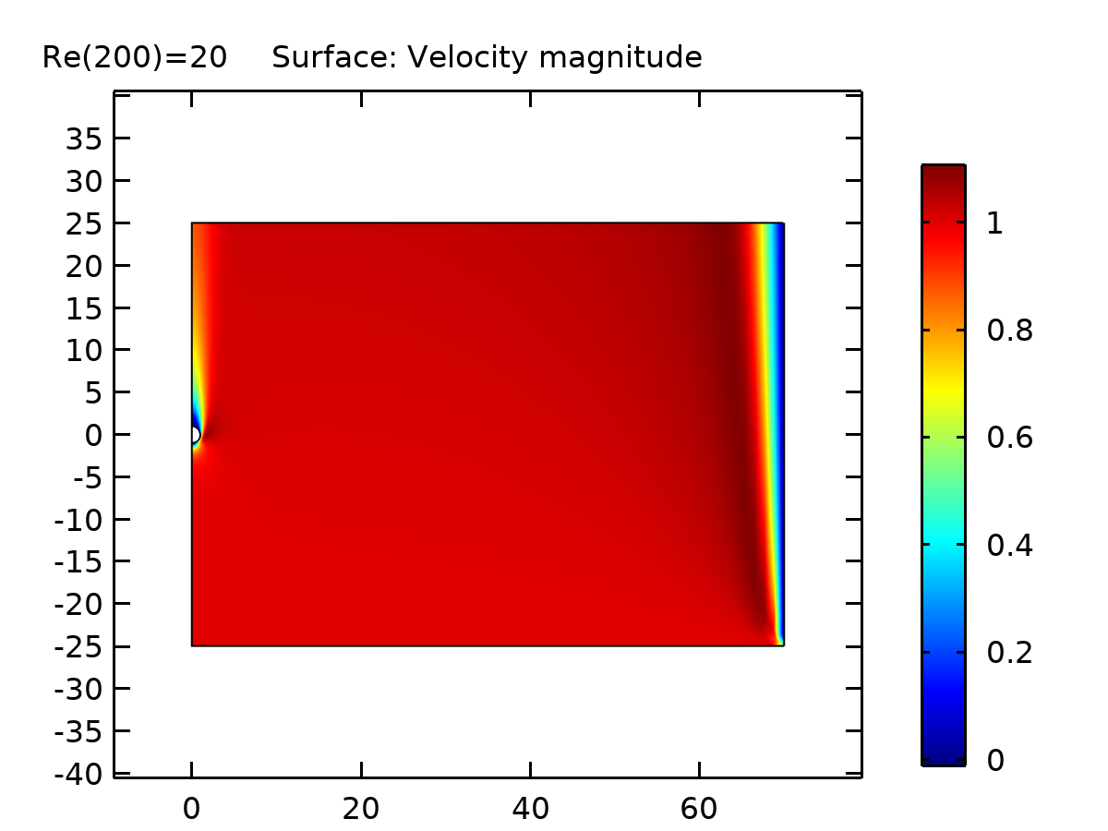

Surface: Velocity magnitude

* + 1. Velocity, 3D (spf)

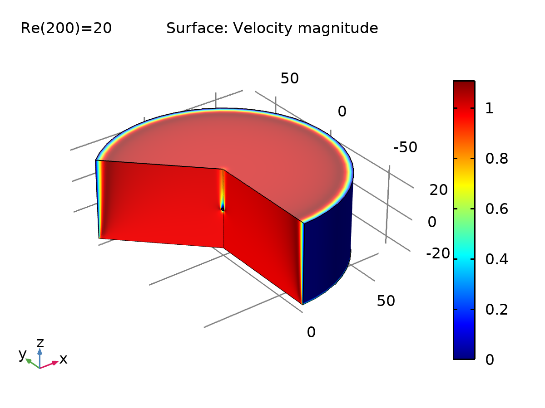

Surface: Velocity magnitude

* + 1. Pressure (spf)

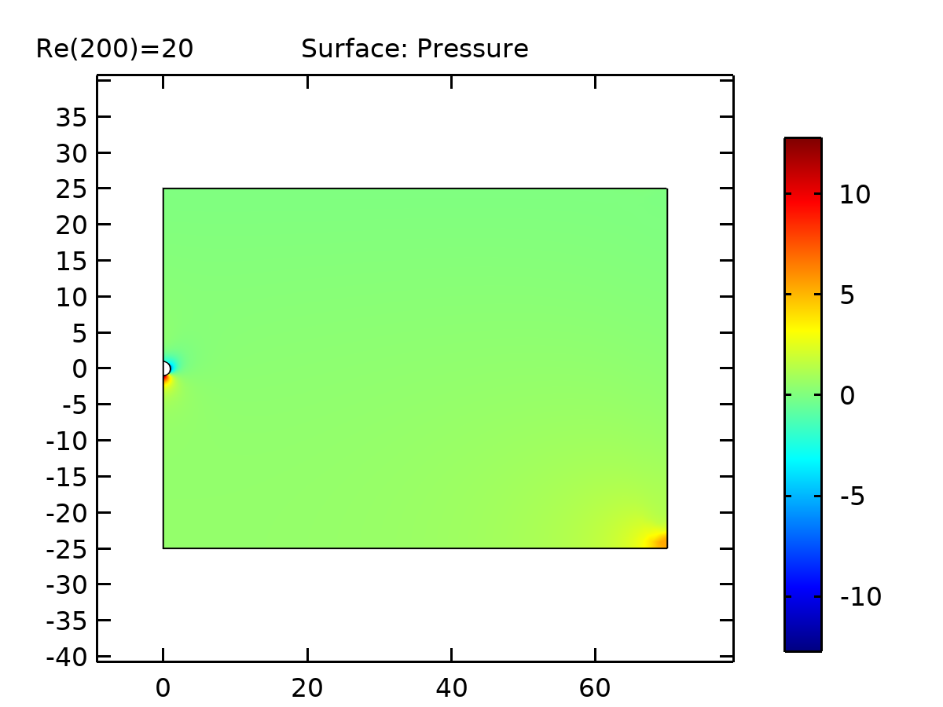

Surface: Pressure

* + 1. Surface Stress vs Arc Length

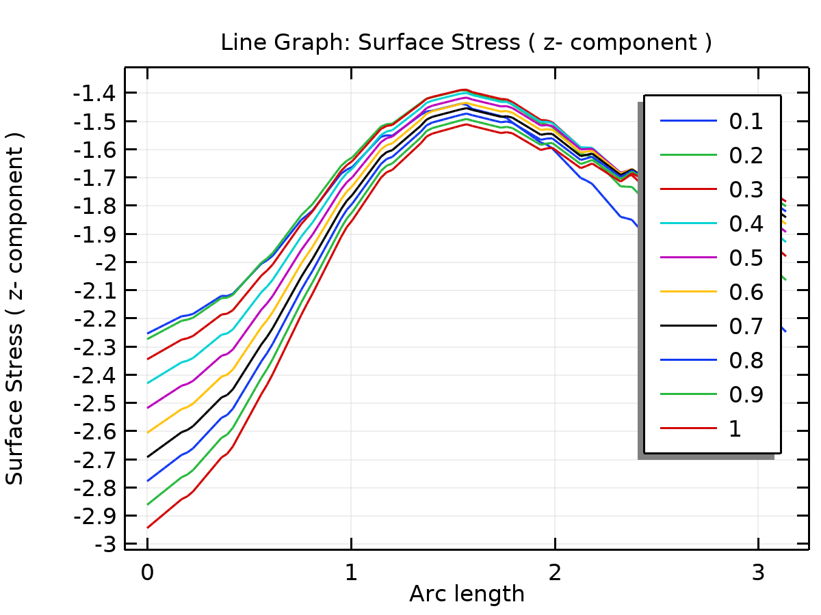

Line Graph: Surface Stress ( z- component )

* + 1. Drag Force vs Re

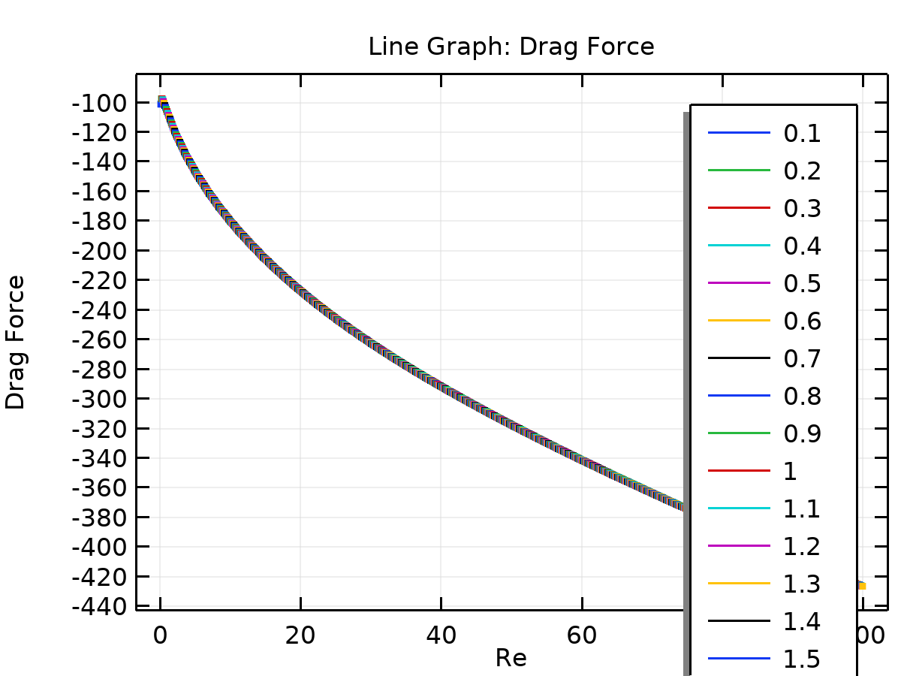

Line Graph: Drag Force

* + 1. Drag Coefficient vs Re

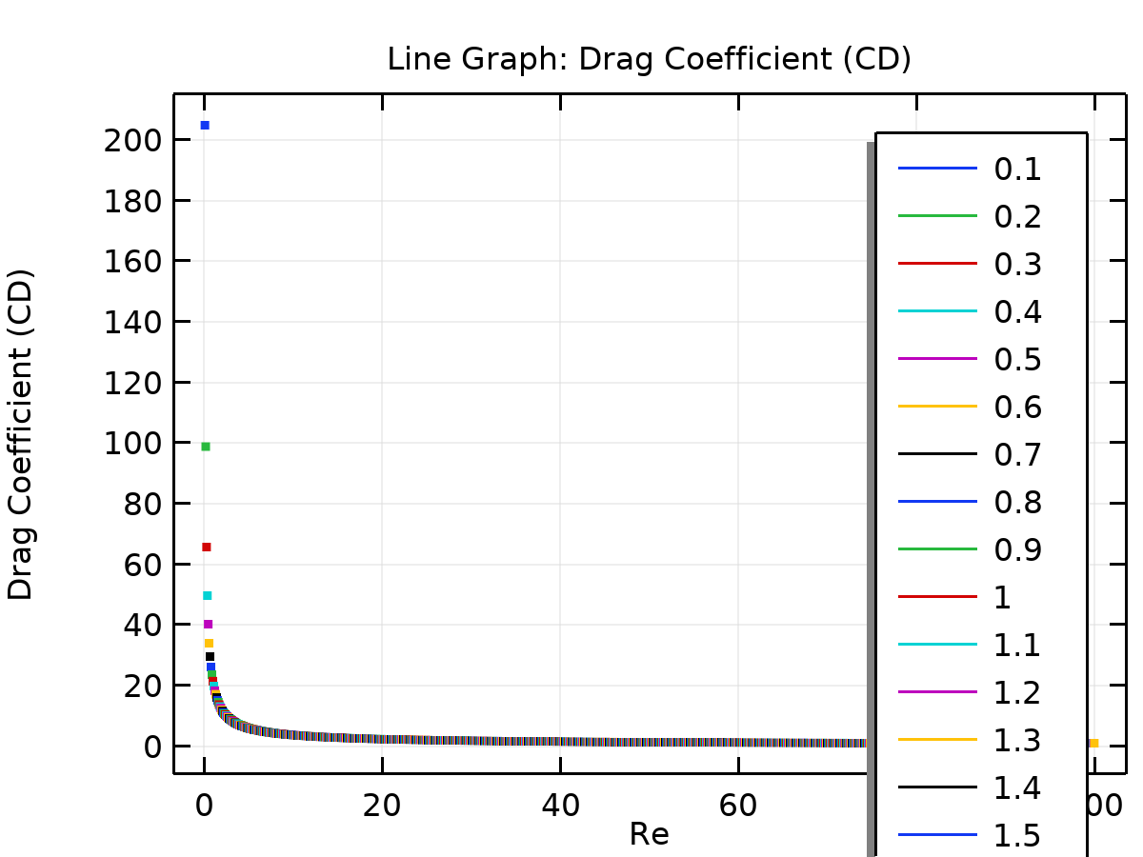

Line Graph: Drag Coefficient (CD)